|  |  |
| --- | --- |
| ASSIGNMENT  Module 2 : Object Oriented Programming in JAVA | Abstract  In this assignment, I have completed 23 questions on java basic topics like decision making statement, loop and arrays. Every question starts from new page along with its code and output.  sarang deodhar  220350320026 |

**Q1.** Design a Java program to get a number from user and find the given number is

positive or negative. Display the message.

**Code :**

**package** module2;

**import** java.util.Scanner;

**public** **class** Q1 {

**public** **static** **void** main(String[] args) {

Scanner sc = **new** Scanner(System.***in***);

System.***out***.println("Enter the number : ");

**int** a = sc.nextInt();

**if**(a<0) {

System.***out***.println(a+" is Negative Number.");

}

**else** **if**(a>0) {

System.***out***.println(a+" is Positive Number");

}

sc.close();

}

}

**Output :**

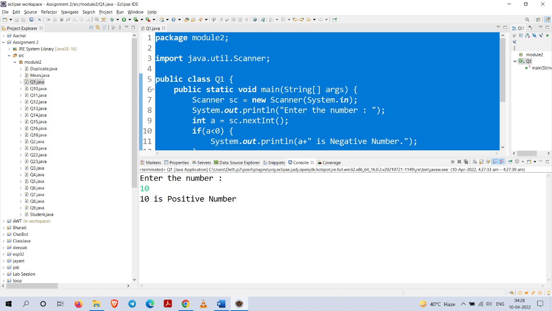

**Q2.** Write a Java program to calculate a Factorial of a number

**Code :**

**package** module2;

**import** java.util.Scanner;

**public** **class** Q2 {

**public** **static** **void** main(String[] args) {

Scanner sc = **new** Scanner(System.***in***);

System.***out***.println("Enter the number : ");

**int** a = sc.nextInt();

**int** fact=1;

**while**(a>=1) {

fact = fact * a;

a--;

}

System.***out***.println("Factorial : "+fact);

sc.close();

}

}

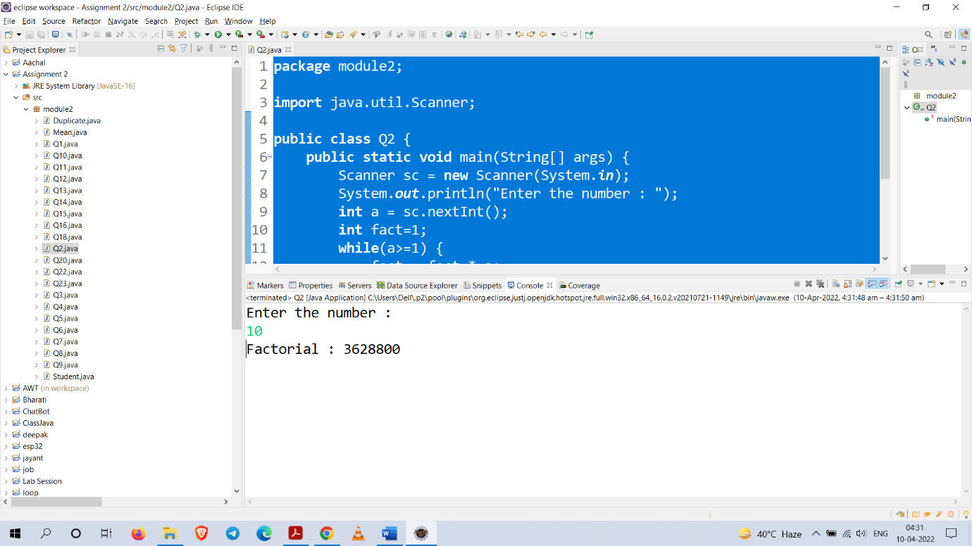**Output :**

**Q3.** Write a Java program to get the age of a person and find the age group of that person as

**Code :**

**package** module2;

**import** java.util.Scanner;

**public** **class** Q3 {

**public** **static** **void** main(String[] args) {

Scanner sc = **new** Scanner(System.***in***);

System.***out***.println("Enter the number : ");

**int** a = sc.nextInt();

**if**(a<=3) {

System.***out***.println("Toddlers");

}**else** **if**(a<=8) {

System.***out***.println("Kids");

}**else** **if**(a<=12) {

System.***out***.println("Child");

}**else** **if**(a<=18) {

System.***out***.println("Teens");

}**else** **if**(a<=40) {

System.***out***.println("Adults");

}**else** **if**(a<=60) {

System.***out***.println("Matured Adults");

}**else** **if**(a<=75) {

System.***out***.println("Seniors");

}**else** **if**(a>76) {

System.***out***.println("Super Seniors");

}

sc.close();

}

}

**Output :** 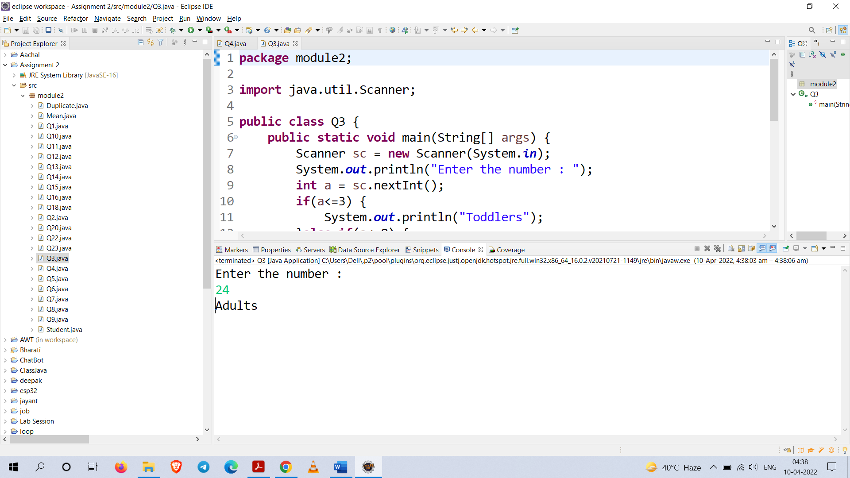

**Q4.** Write a program called CozaLozaWoza which prints the numbers 1 to 110, 11 numbers per line.

The program shall print "Coza" in place of the numbers which are multiples of 3, "Loza" for

multiples of 5, "Woza" for multiples of 7, "CozaLoza" for multiples of 3 and 5, and so on.

**The output shall look like:**

1 2 Coza 4 Loza Coza Woza 8 Coza Loza 11

Coza 13 Woza CozaLoza 16 17 Coza 19 Loza CozaWoza 22

23 oza Loza 26 Coza Woza 29 CozaLoza 31 32 Coza

**Code :**

**package** module2;

**public** **class** Q4 {

**public** **static** **void** main(String[] args) {

**for**(**int** i=1;i<=110;i++) {

**if**(i%3==0 && i%5==0)

System.***out***.print("CozaLoza");

**else** **if**(i%3==0)

System.***out***.print("Coza");

**else** **if**(i%5==0)

System.***out***.print("Loza");

**if**(i%7==0)

System.***out***.print("Woza");

**if**(i%3!=0 && i%5!=0 && i%7!=0)

System.***out***.print(i);

**if**(i%11==0) {

System.***out***.println();

**continue**;

}

System.***out***.print(" ");

}

}

}

**Output :**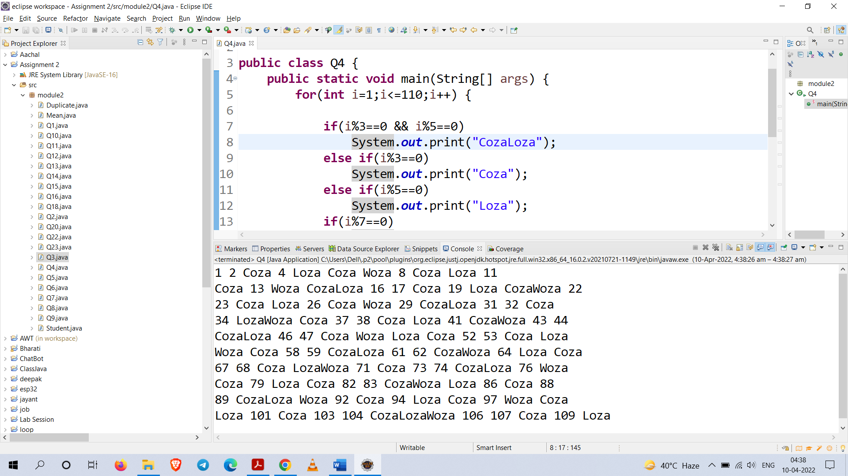

**Q5.** Write a Java code to get a number and find whether it is prime number or not. (note:Prime number is the number divisible by 1 and itself only)

**Code :**

**package** module2;

**import** java.util.Scanner;

**public** **class** Q5 {

**public** **static** **void** main(String[] args) {

Scanner sc = **new** Scanner(System.***in***);

System.***out***.println("Enter a number : ");

**int** a = sc.nextInt();

**int** count = 0;

**for**(**int** i=2;i<=a/2;i++) {

**if**(a%i==0) {

count++;

**break**;

}

}

**if**(count == 0)

System.***out***.println(a+" is a prime number.");

**else** **if**(count == 1)

System.***out***.println(a+" is a not prime number.");

sc.close();

}

}

**Output :**

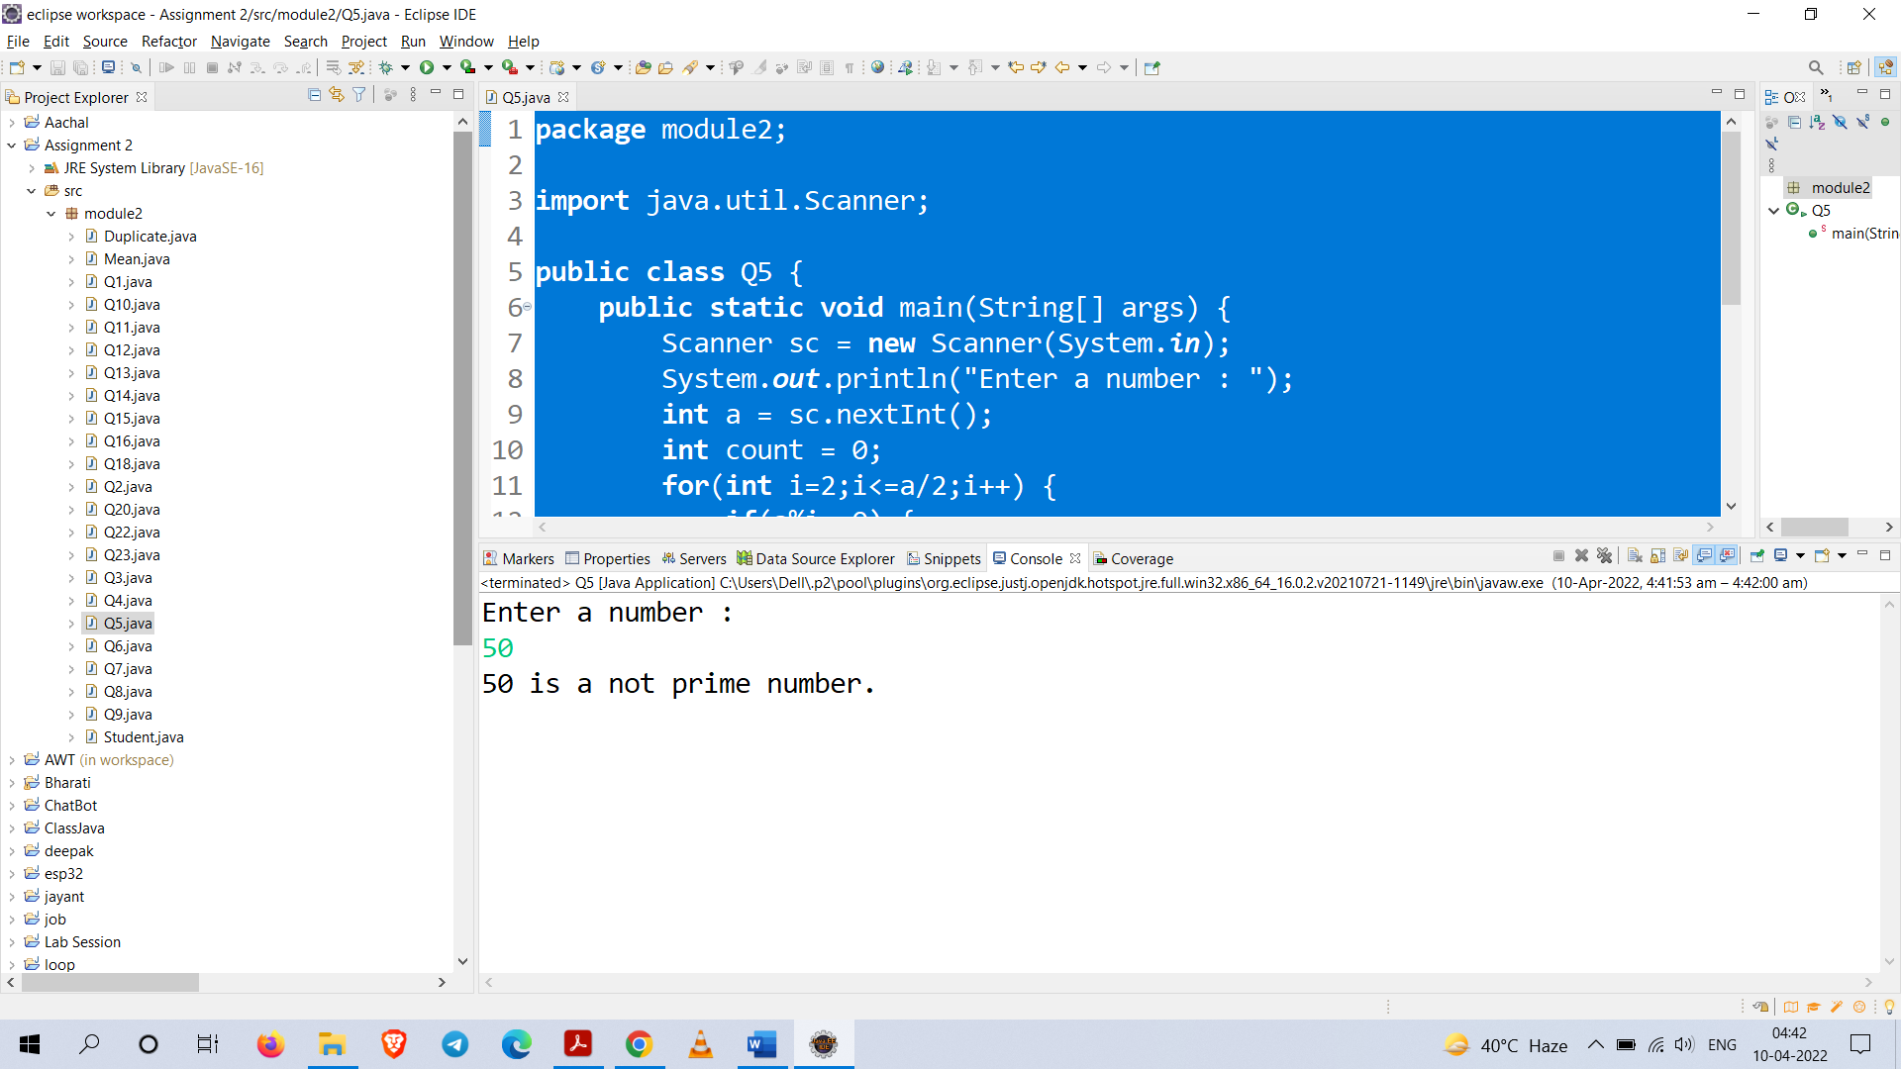

**Q6.** Design a Java program to print the following pattern for the positive value ‘n’. Sample Output.



**Code :**

**package** module2;

**import** java.util.Scanner;

**public** **class** Q6 {

**public** **static** **void** main(String[] args) {

Scanner sc = **new** Scanner(System.***in***);

**int** n = sc.nextInt();

**for**(**int** i=1;i<=n;i++) {

**for**(**int** j=1;j<=n-i;j++) {

System.***out***.print(" ");

}

**for**(**int** k=1;k<=i;k++) {

System.***out***.print("* ");

}

System.***out***.println();

}

sc.close();

}

}

**Output :** 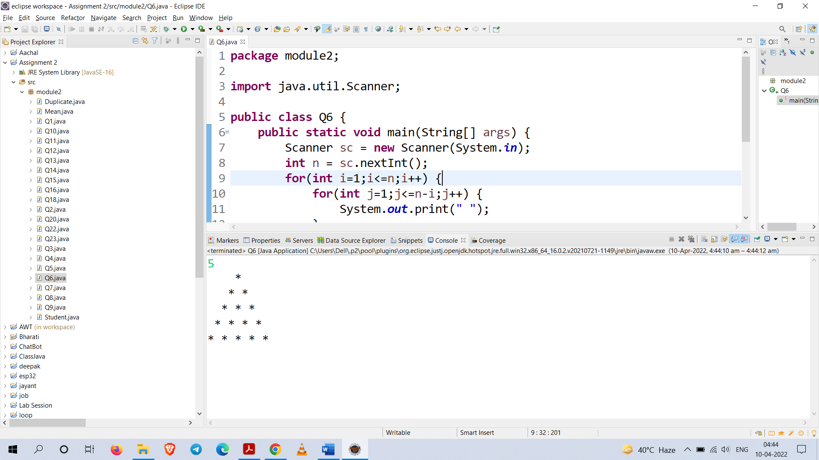

**Q7.** Write a Java program that will read in month and day (as numerical value). The program will return the equivalent zodiac sign.



**Code :**

**package** module2;

**import** java.util.Scanner;

**public** **class** Q7 {

**public** **static** **void** main(String[] args) {

**enum** Zodiac{***Aquarius***, ***Pisces***, ***Aries***, ***Taurus***,

***Gemini***,***Cancer***,***Leo***,***Virgo***,***Libra***,***Scorpio***,***Sagittarius***,

***Capricorn***};

**enum** Month{***January***,***February***,***March***,***April***,***May***,***June***,***July***,***August***,

***September***,***October***,***November***,***December***};

Scanner sc = **new** Scanner(System.***in***);

System.***out***.println("Enter the Day : ");

**int** day = sc.nextInt();

System.***out***.println("Enter the Month (1-12) : ");

**int** Mon = sc.nextInt();

Month M[]= Month.*values*();

Zodiac z[] = Zodiac.*values*();

Mon=Character.*toLowerCase*(Mon);

**if**(Mon==1)

{

**if**(day>=1 && day<=19)

System.***out***.println("Zodic sign for "+M[Mon-1]+" "+day+" is "+z[11]);

**if**(day>=20 && day<=31)

System.***out***.println("Zodiac sign for "+M[Mon-1]+" "+day+" is "+z[Mon]);

}

**else** **if**(Mon==2)

{

**if**(day>=1 && day<=18)

System.***out***.println("Zodiac sign for "+M[Mon-1]+" "+day+" is "+z[Mon-1]);

**if**(day>=19 && day<=29)

System.***out***.println("Zodic sign for "+M[Mon-1]+" "+day+" is "+z[Mon]);

}**else** **if**(Mon==3)

{

**if**(day>=1 && day<=20)

System.***out***.println("Zodiac sign for "+M[Mon-1]+" "+day+" is "+z[Mon-1]);

**if**(day>=21 && day<=31)

System.***out***.println("Zodic sign for "+M[Mon-1]+" "+day+" is "+z[Mon]);

}**else** **if**(Mon==4)

{

**if**(day>=1 && day<=19)

System.***out***.println("Zodiac sign for "+M[Mon-1]+" "+day+" is "+z[Mon-1]);

**if**(day>=20 && day<=30)

System.***out***.println("Zodic sign for "+M[Mon-1]+" "+day+" is "+z[Mon]);

}**else** **if**(Mon==5)

{

**if**(day>=1 && day<=20)

System.***out***.println("Zodiac sign for "+M[Mon-1]+" "+day+" is "+z[Mon-1]);

**if**(day>=21 && day<=31)

System.***out***.println("Zodic sign for "+M[Mon-1]+" "+day+" is "+z[Mon]);

}**else** **if**(Mon==6)

{

**if**(day>=1 && day<=20)

System.***out***.println("Zodiac sign for "+M[Mon-1]+" "+day+" is "+z[Mon-1]);

**if**(day>=21 && day<=30)

System.***out***.println("Zodic sign for "+M[Mon-1]+" "+day+" is "+z[Mon]);

}**else** **if**(Mon==7)

{

**if**(day>=1 && day<=22)

System.***out***.println("Zodiac sign for "+M[Mon-1]+" "+day+" is "+z[Mon-1]);

**if**(day>=23 && day<=31)

System.***out***.println("Zodic sign for "+M[Mon-1]+" "+day+" is "+z[Mon]);

}

**else** **if**(Mon==8)

{

**if**(day>=1 && day<=22)

System.***out***.println("Zodiac sign for "+M[Mon-1]+" "+day+" is "+z[Mon-1]);

**if**(day>=23 && day<=31)

System.***out***.println("Zodic sign for "+M[Mon-1]+" "+day+" is "+z[Mon]);

}

**else** **if**(Mon==9)

{

**if**(day>=1 && day<=22)

System.***out***.println("Zodiac sign for "+M[Mon-1]+" "+day+" is "+z[Mon-1]);

**if**(day>=23 && day<=30)

System.***out***.println("Zodic sign for "+M[Mon-1]+" "+day+" is "+z[Mon]);

}**else** **if**(Mon==10)

{

**if**(day>=1 && day<=22)

System.***out***.println("Zodiac sign for "+M[Mon-1]+" "+day+" is "+z[Mon-1]);

**if**(day>=23 && day<=31)

System.***out***.println("Zodic sign for "+M[Mon-1]+" "+day+" is "+z[Mon]);

}**else** **if**(Mon==11)

{

**if**(day>=1 && day<=21)

System.***out***.println("Zodiac sign for "+M[Mon-1]+" "+day+" is "+z[Mon-1]);

**if**(day>=22 && day<=30)

System.***out***.println("Zodic sign for "+M[Mon-1]+" "+day+" is "+z[Mon]);

}**else** **if**(Mon==12)

{

**if**(day>=1 && day<=21)

System.***out***.println("Zodiac sign for "+M[Mon-1]+" "+day+" is "+z[Mon-1]);

**if**(day>=22 && day<=31)

System.***out***.println("Zodic sign for "+M[Mon-1]+" "+day+" is "+z[Mon]);

}

sc.close();

}

}

**Output :**

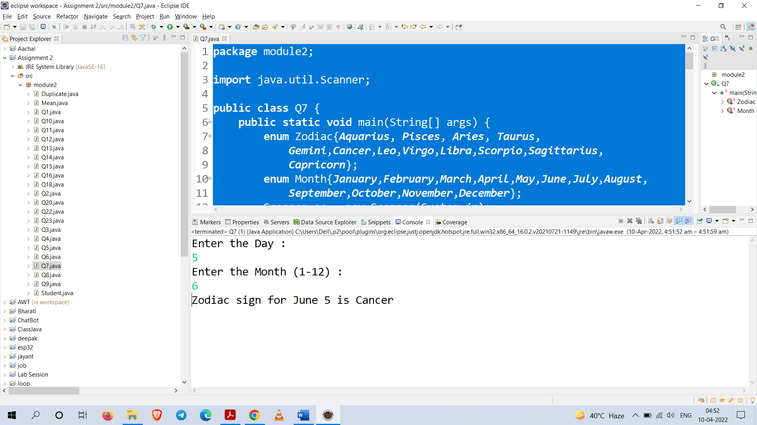

**Q8.** Write Java code statements that accomplish the tasks listed below

1. Declare an array of integers.
2. Allocate storage to allow 5 integers to be stored in the array.
3. Populate the array with the values: 1, 8, 27, 64, 125
4. Replace the third array element with the value -7.
5. Copy the value of the fifth array element to the first array storage location.
6. Subtract the value stored in the second array storage location from the value stored in the
7. third and store the difference in the fourth array storage location.
8. Compute the sum of the array elements with subscripts 1 to 3.

**Code :**

**package** module2;

**public** **class** Q8 {

**public** **static** **void** main(String[] args) {

**int** b=0,sum=0;

System.***out***.println("Task a");

**int** a[];

System.***out***.println("Array of integer is declared.\n");

System.***out***.println("Task b");

a = **new** **int**[5];

System.***out***.println("Storage of 5 is allocated.\n");

System.***out***.println("Task c");

**for**(**int** i=0;i<5;i++)

{

b=i+1;

a[i]=(b*b*b);

}

System.***out***.println("Data stored in array.\n");

System.***out***.println("Task d");

a[2]=-7;

System.***out***.println("3rd element is replaced to -7.\n");

System.***out***.println("Task e");

a[0] = a[4];

System.***out***.println("value of 5th element is copied in 1st.\n");

System.***out***.println("Task f");

a[3] = a[2] - a[1];

System.***out***.print("second element value is subtracted from value of");

System.***out***.println(" thrid element and stored in fouth element.\n");

System.***out***.println("Task g");

**for**(**int** i = 1 ; i <= 3 ; i++) {

sum+=a[i];

}

System.***out***.println("Sum of subscript 1 to 3 = "+sum);

System.***out***.println("----------------------------------");

System.***out***.println("All tasks completed");

}

}

**Output :** 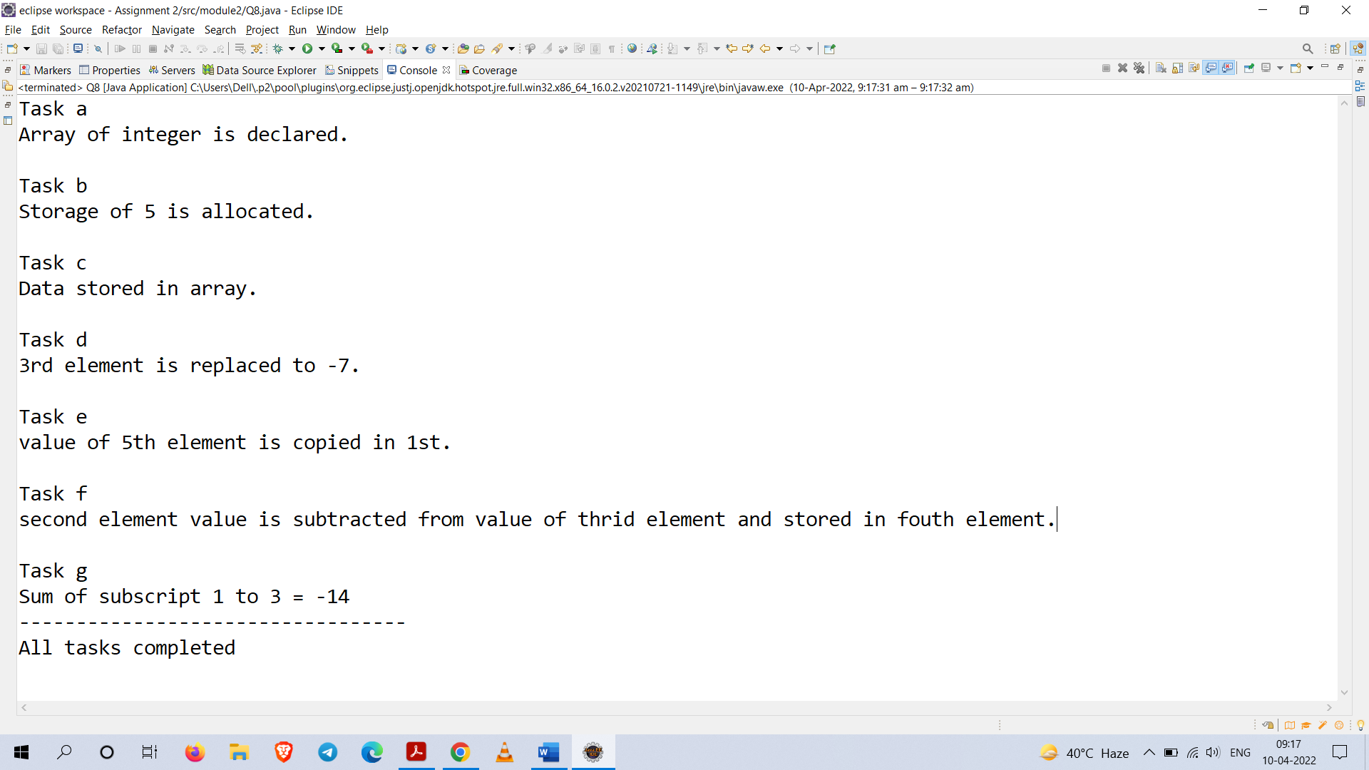

**Q9.** Design a Java code to receive input for ‘n’ numbers and sort numbers based on user’s choice either ascending or descending. Finally print results.

**Code :**

**package** module2;

**import** java.util.Scanner;

**public** **class** Q9 {

**public** **static** **void** main(String[] args) {

Scanner sc = **new** Scanner(System.***in***);

**int**[] a = {1,2,3,9,8,7,6,4,53,4};

**int** temp=0;

System.***out***.println("Array before Sorting...");

**for**(**int** i : a)

System.***out***.print(i+" ");

System.***out***.println();

System.***out***.println("-----------------------");

//sorting array Arrays.sort(a);

**for**(**int** i = 0 ; i < a.length ; i++) {

**for**(**int** j = i+1 ; j < a.length ; j++) {

**if**(a[i] > a[j]) {

temp = a[i];

a[i] = a[j];

a[j] = temp;

}

}

}

System.***out***.println("For Sorting array in Ascending order press a");

System.***out***.println("For Sorting array in Descending order press d");

System.***out***.print("=> ");

**char** c = sc.next().charAt(0);

System.***out***.println("-----------------------");

**if**('a' == Character.*toLowerCase*(c)) {

System.***out***.println("Ascending order...");

**for**(**int** b : a)

System.***out***.print(b+" ");

}

**else** **if**('d' == Character.*toLowerCase*(c)) {

System.***out***.println("Descending order...");

**for**(**int** i = a.length - 1; i >= 0; i--)

System.***out***.print(a[i]+" ");

}

sc.close();

}

}

**Output :**

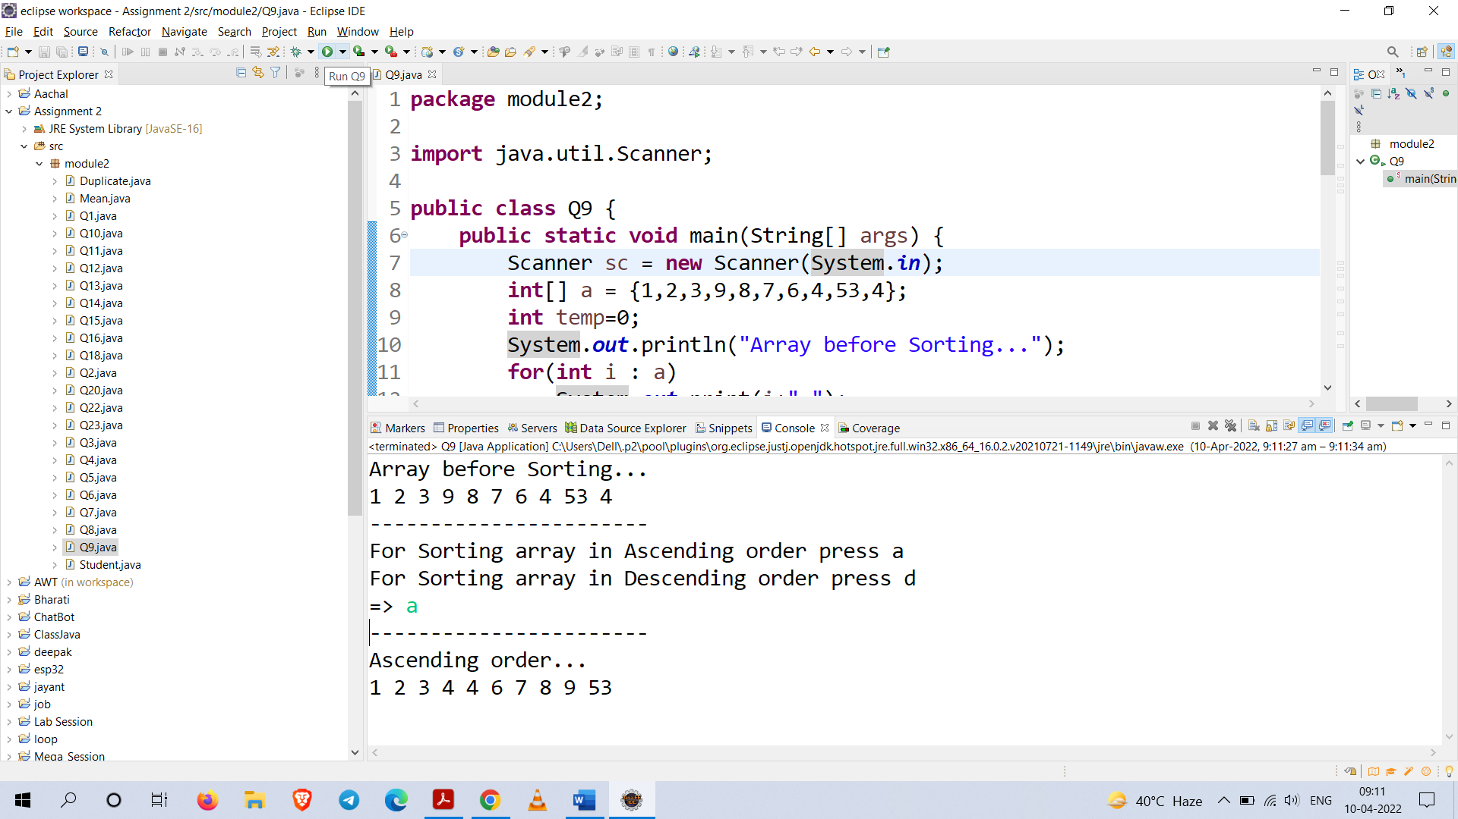

**Q10.** Design a Java program to get a string and do the following in the same program.

1. Get a character. Find the occurrence of the character from right and left side. Display that

information separately.

1. Get a positive integer from user and find the character of the index such that should not

create run time error.

**Code :**

**package** module2;

**import** java.util.Scanner;

**public** **class** Q10 {

**public** **static** **void** main(String[] args) {

**boolean** foundChar = **false**;

**boolean** intFound = **false**;

System.***out***.print("Enter the string : ");

Scanner sc = **new** Scanner(System.***in***);

String str = sc.next();

System.***out***.print("Enter the Character :");

**char** ch = sc.next().charAt(0);

System.***out***.println("Searching input character in string...");

**for**(**int** i = 0 ; i < str.length() ; i++) {

**if**(ch == str.charAt(i)) {

System.***out***.print(ch+" is found at location : "+(str.length()-i));

System.***out***.println(" from right and " +(i+1)+ " from left.");

foundChar = **true**;

}

}

**if**(foundChar == **false**) {

System.***out***.println("Given character is not found ");

System.***out***.print("Program is terminating...");

System.*exit*(0);

}

System.***out***.println("Task 1 Completed");

System.***out***.println("-----------------\n");

System.***out***.print("Enter positive number between 0 to "+(str.length()-1));

**int** a = sc.nextInt();

**if**(a < str.length()) {

intFound = **true**;

}

**if**(intFound == **false**) {

System.***out***.println("Given index is out of range");

System.***out***.print("Program is terminating...");

System.*exit*(0);

}

System.***out***.println("Searching for character for given index...");

System.***out***.println("Character at index "+a+" is : "+str.charAt(a));

System.***out***.println("Task 2 Completed");

sc.close();

}

}

**Output :**

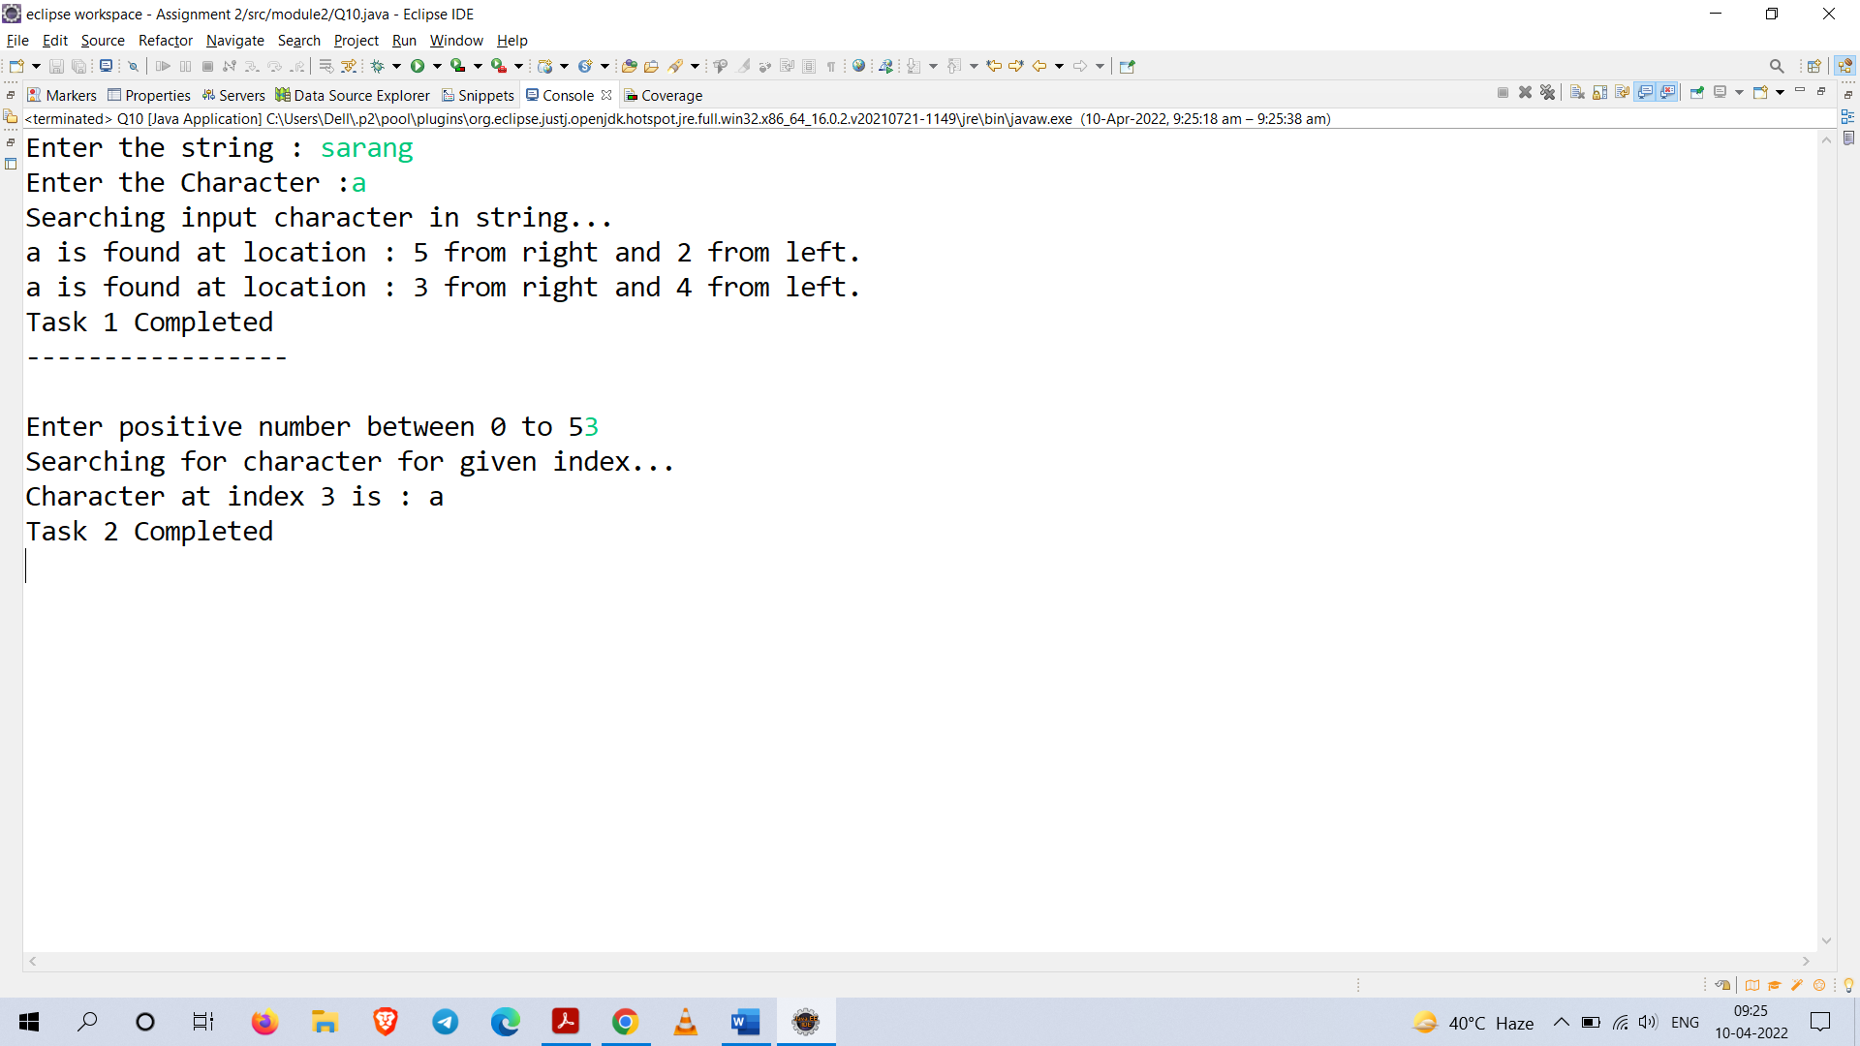

**Q11.** Design a Java program to get ‘n’ numbers and a number. Apply the linear search and binary

search. Find the best algorithm through the computation and display the result.

**Code :**

package module2;

import java.util.Arrays;

import java.util.Scanner;

public class Q11 {

public static void main(String[] args) {

Scanner sc = new Scanner(System.in);

int a[] = new int[5];

int temp = 0;

//input

System.out.println("Enter 5 random numbers : ");

for(int i = 0 ; i < a.length ; i++)

a[i] = sc.nextInt();

//sorting

for(int i = 0 ; i < a.length ; i++) {

for(int j = i+1 ; j < a.length ; j++) {

if(a[i] > a[j]) {

temp = a[i];

a[i] = a[j];

a[j] = temp;

}

}

}

//Key

int key = sc.nextInt();

//Linear Search

long start, end;

start = System.nanoTime();

for(int i = 0 ; i < a.length ; i++) {

if(a[i]==key) {

break;

}

}

end = System.nanoTime();

long linearEfficiency = end - start;

//Binary Search

start = System.nanoTime();

Arrays.binarySearch(a, key);

end = System.nanoTime();

long binaryEfficiency = end - start;

//output

System.out.println("Result : ");

System.out.println("--------");

System.out.println("Computation efficiency of linear search : " +

linearEfficiency+"ns and Binary search : "+binaryEfficiency+"ns");

System.out.println("------------------------------------");

System.out.println("Conclusion :");

System.out.println("------------");

if(linearEfficiency < binaryEfficiency)

System.out.println("linear search is reliable than binary search");

else

System.out.println("binary search is reliable than linear search");

sc.close();

}

}

**Output :**

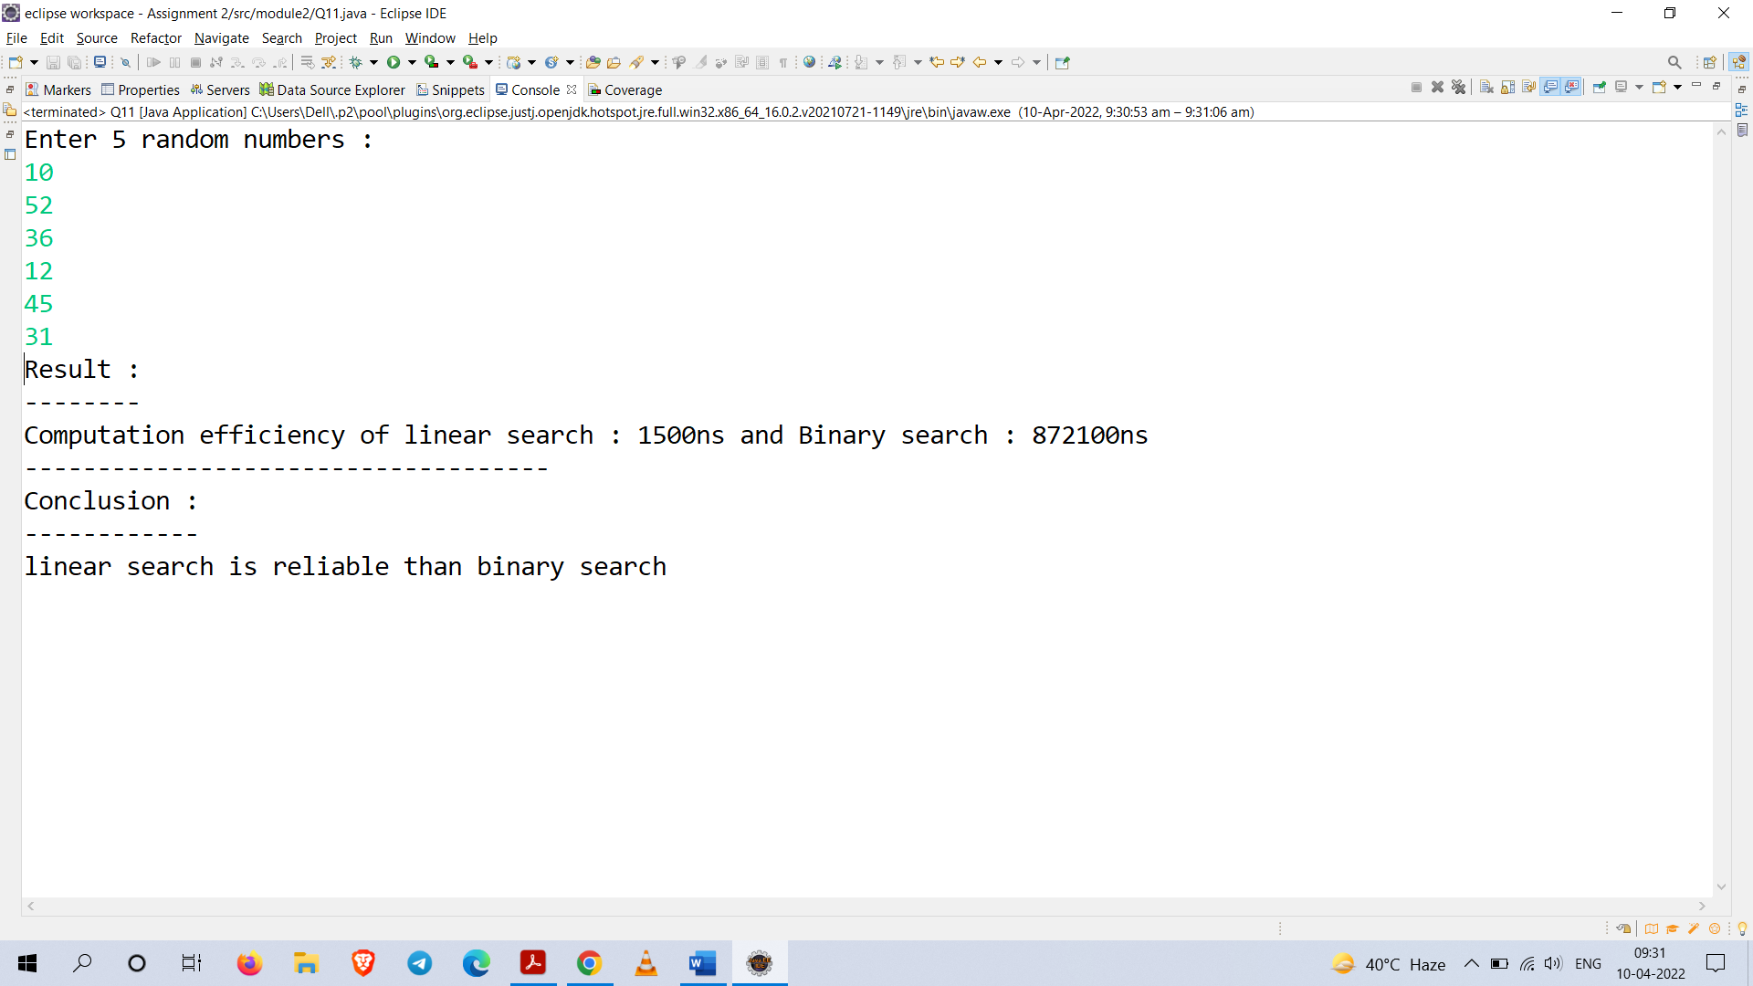

**Q12.** Design a Java Program to get a matrix as input and print the transpose of the given matrix.

**Code :**

**package** module2;

**import** java.util.Scanner;

**public** **class** Q12 {

**public** **static** **void** main(String[] args) {

Scanner sc = **new** Scanner(System.***in***);

System.***out***.print("Enter the size first dimension of array");

**int** n1 = sc.nextInt();

System.***out***.print("Enter the size second dimension of array");

**int** n2 = sc.nextInt();

**int** a[][] = **new** **int**[n1][n2];

**int** b[][] = **new** **int**[n1][n2];

System.***out***.println("Enter the elements of matrix : ");

//input elements of matrix

**for**(**int** i = 0 ; i < n1 ; i++) {

**for**(**int** j = 0 ; j < n2 ; j++) {

a[i][j] = sc.nextInt();

}

}

//display original matrix

System.***out***.println("===================");

System.***out***.println("Original Matrix : ");

System.***out***.println("===================");

**for**(**int** x = 0 ; x < a.length; x++) {

System.***out***.print(" ");

**for**(**int** y = 0 ; y < a.length; y++)

System.***out***.print(a[x][y]+" ");

System.***out***.println();

}

//Transpose

**for**(**int** i = 0 ; i < n1 ; i++) {

**for**(**int** j = 0 ; j < n2 ; j++) {

b[i][j] = a[j][i];

}

}

//display transpose output

System.***out***.println("======================");

System.***out***.println("Transpose of Matrix : ");

System.***out***.println("======================");

**for**(**int** i = 0 ; i < n1 ; i++) {

System.***out***.print(" ");

**for**(**int** j = 0 ; j < n2 ; j++) {

System.***out***.print(b[i][j]+" ");

}

System.***out***.println();

}

sc.close();

}

}

**Output :**

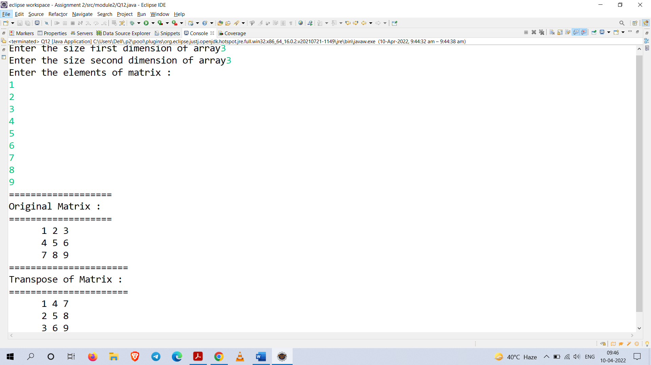

**Q13.** Develop a Java program to get a matrix and print the lower triangle of the matrix. Apply the necessary conditions if it required.

**Code :**

**package** module2;

**import** java.util.Scanner;

**public** **class** Q13 {

**public** **static** **void** main(String[] args) {

Scanner sc = **new** Scanner(System.***in***);

**int** n1,n2;

//no of rows

System.***out***.print("Enter the rows of the matrix : ");

n1 = sc.nextInt();

//no of columns

System.***out***.print("Enter the column of the matrix : ");

n2 = sc.nextInt();

//creating array of dimensions n1 x n2

**int** a[][] = **new** **int**[n1][n2];

//taking input

System.***out***.println("Enter the elements of array : ");

**for**(**int** i = 0 ; i < n1 ; i++) {

**for**(**int** j = 0 ; j < n2 ; j++) {

a[i][j] = sc.nextInt();

}

}

//printing the matrix

System.***out***.println("========================");

System.***out***.println("Lower Triangle Matrix : ");

System.***out***.println("========================");

**for**(**int** i = 0 ; i < n1 ; i++) {

System.***out***.print(" ");

**for**(**int** j = 0 ; j < n2 ; j++) {

**if**(i < j) {

a[i][j] = 0;

}

System.***out***.print(a[i][j]+" ");

}

System.***out***.println();

}

System.***out***.println("========================");

sc.close();

}

}

**Output :**

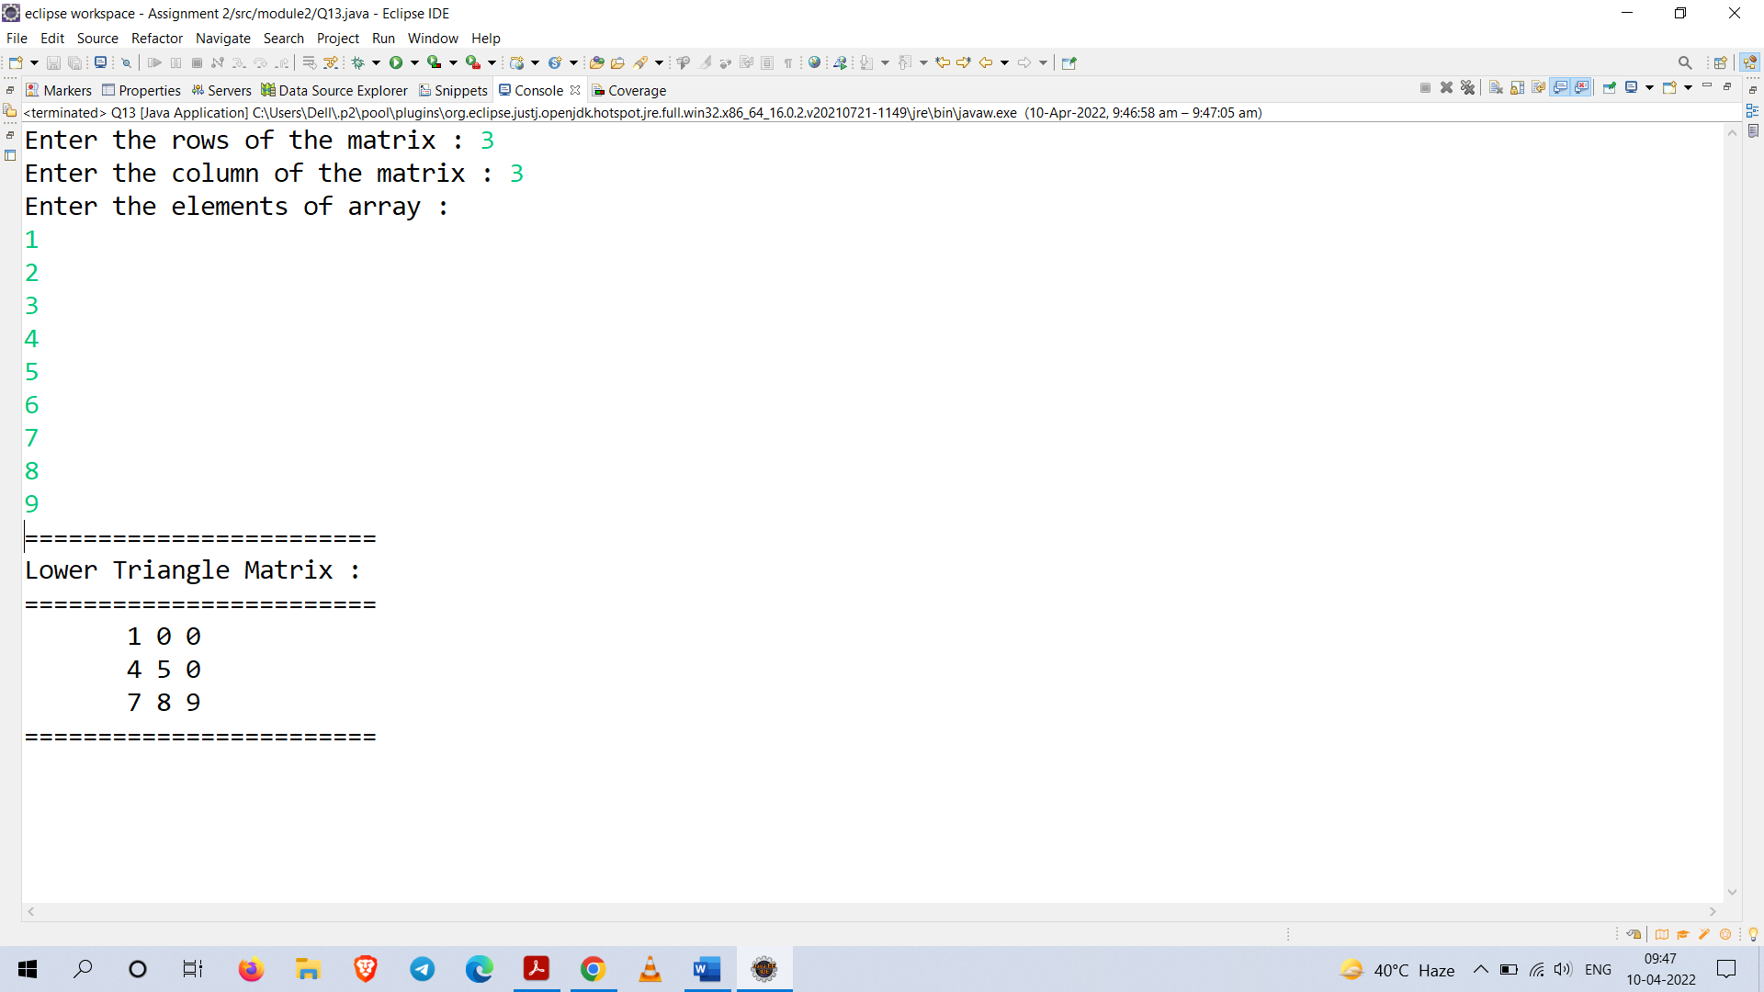

**Q14.** Get ‘n’ integer numbers from user and find the count of each unique number. Display the result as number – its count. Example: 3 - 5, where 3 is the number presented for 5 times)

**Code :**

**package** module2;

**import** java.util.Scanner;

**public** **class** Q14 {

**public** **static** **void** main(String[] args) {

**int** n = 0;

**int** count = 0;

**boolean** check = **false**;

Scanner sc = **new** Scanner(System.***in***);

System.***out***.println("Enter the number of elements : ");

n = sc.nextInt();

**int** a[] = **new** **int**[n];

**int** i = 0;

System.***out***.println("Enter "+n+" elements");

**for**(@SuppressWarnings("unused") **int** x : a) {

a[i] = sc.nextInt();

i++;

}

**for**(**int** k = 0 ; k < a.length ; k++) {

check =**false**;

count = 0;

**for**(**int** j = k ; j < a.length ; j++) {

**for**(**int** z = 0 ; z < k ; z++) {

**if**(a[z] == a[k])

{

check = **true**;

**break**;

}

}

**if**(check == **true**)

**continue**;

**if**(a[k] == a[j])

count++;

}

**if**(check == **false**)

System.***out***.println(a[k]+" - "+count);

}

sc.close();

}

}

**Output :**

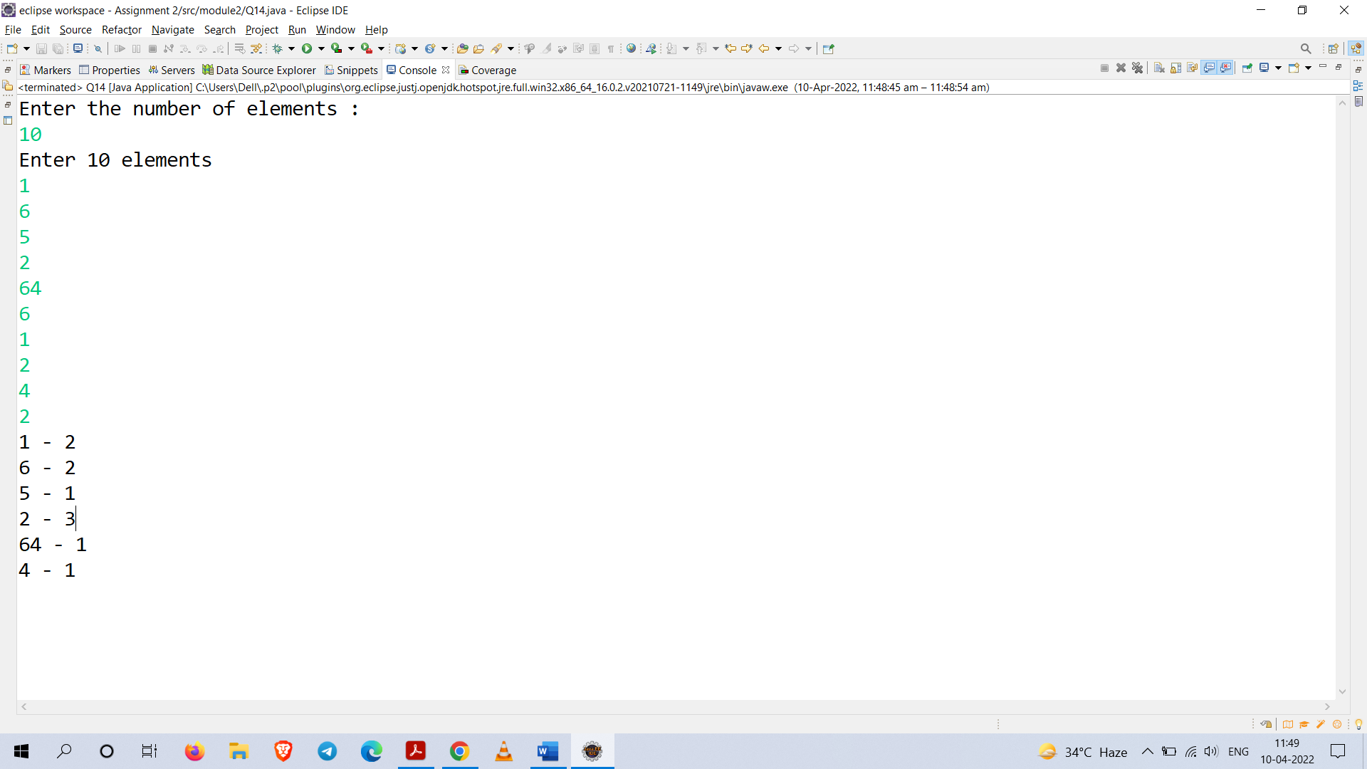

**Q15.** Write a Java program to get a string from user. Divide the given string into 5 equals parts and make those part as new string. At last, print all information. Apply the necessary conditions

**Code :**

**package** module2;

**import** java.util.Scanner;

**public** **class** Q15 {

**public** **static** **void** main(String[] args) {

Scanner sc = **new** Scanner(System.***in***);

String str = sc.nextLine();

**if**(str.length()%5!=0) {

System.***out***.println(str.length());

System.***out***.println("Cannot be divided into 5 parts.");

System.*exit*(0);

}

String[] sho = **new** String[5];

**int** j = 0 , count = 0 ;

sho[j]="";

**for**(**int** i = 0 ; i < str.length() ; i++) {

**if**(count == (str.length()/5)) {

j++;

count = 0;

sho[j]="";

}

count++;

sho[j] += str.charAt(i);

}

System.***out***.println("\nOutput : ");

System.***out***.println("---------");

**for**(String x : sho)

System.***out***.println(x);

sc.close();

}

}

**Output :**

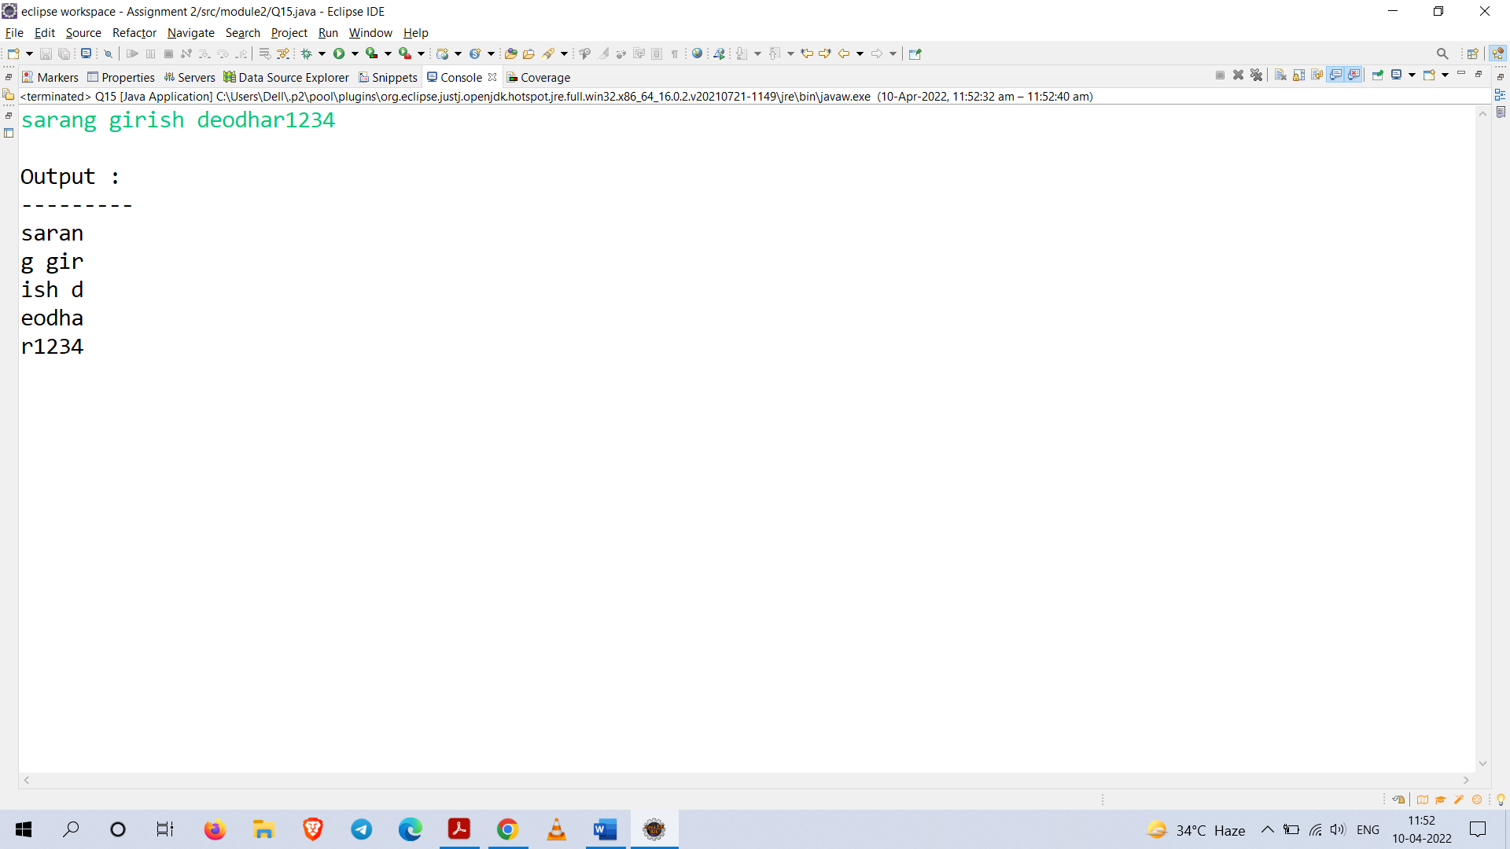

**Q16.** Design a Java Program to represent time as class which contains the following:

1. Hours, minutes and seconds as members.
2. Basic Methods to get input, print the time.
3. Method to find the difference between two times.

Demonstrate these methods through few objects. Also apply the necessary conditions

**Code :**

**package** module2;

**import** java.util.Scanner;

**public** **class** Q16 {

**static** Scanner *sc*;

**private** **int** hours;

**private** **int** minutes;

**private** **int** seconds;

**private** **int** valid = 1;

**private** **static** **int** *count* = 0;

**static** Q16 *end*;

**static** Q16 *start*;

**static** Q16 *diff*;

**public** **void** input() {

*sc* = **new** Scanner(System.***in***);

**while**(valid==1) {

valid = 0;

**if**(*count* == 0) {

System.***out***.println("Starting Time : ");

}

**else** **if**(*count* == 1) {

System.***out***.println("Ending Time : ");

}

System.***out***.print("Enter the hours, minutes and seconds : ");

hours = *sc*.nextInt();

minutes = *sc*.nextInt();

seconds = *sc*.nextInt();

**if**(hours > 24 || hours < 0 || minutes > 60 || minutes < 0 || seconds > 60 || seconds < 0)

{

System.***out***.println("\nInvalid input\n");

valid = 1;

}

**if**(*count*==1) {

**if**(*end*.hours < *start*.hours) {

System.***out***.println("\nInvalid input");

System.***out***.println("End time must be greater than start time\n");

valid = 1;

}

}

}

}

**public** **void** print() {

System.***out***.println(hours+" "+minutes+" "+seconds);

}

**public** **void** difference() {

**this**.hours = *end*.hours - *start*.hours;

**this**.minutes = *end*.minutes - *start*.minutes;

**this**.seconds = *end*.seconds - *start*.seconds;

**if**(seconds < 0) {

seconds += 60;

minutes -= 1;

}

**if**(minutes < 0) {

minutes += 60;

hours -= 1;

}

System.***out***.println("time difference : ");

System.***out***.println(hours+":"+minutes+":"+seconds);

System.***out***.println("\n");

}

**public** **static** **void** main(String[] args) {

**for** (**int** i = 0; i<3; i++)

{

System.***out***.println("For iteration - "+i+" : ");

System.***out***.println("====================");

*start* = **new** Q16();

*end* = **new** Q16();

*diff* = **new** Q16();

*start*.input();

*count*++;

*end*.input();

System.***out***.println("Starting Time : ");

*start*.print();

System.***out***.println("Ending Time : ");

*end*.print();

*diff*.difference();

*count*=0;

}

*sc*.close();

}

}

**Output :**

Part 1

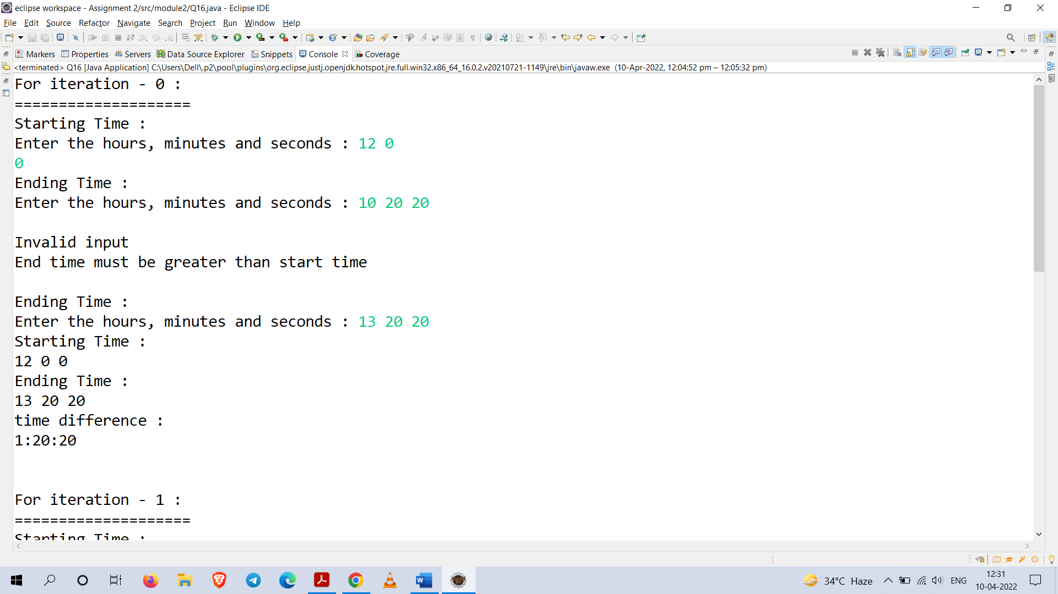

Part 2

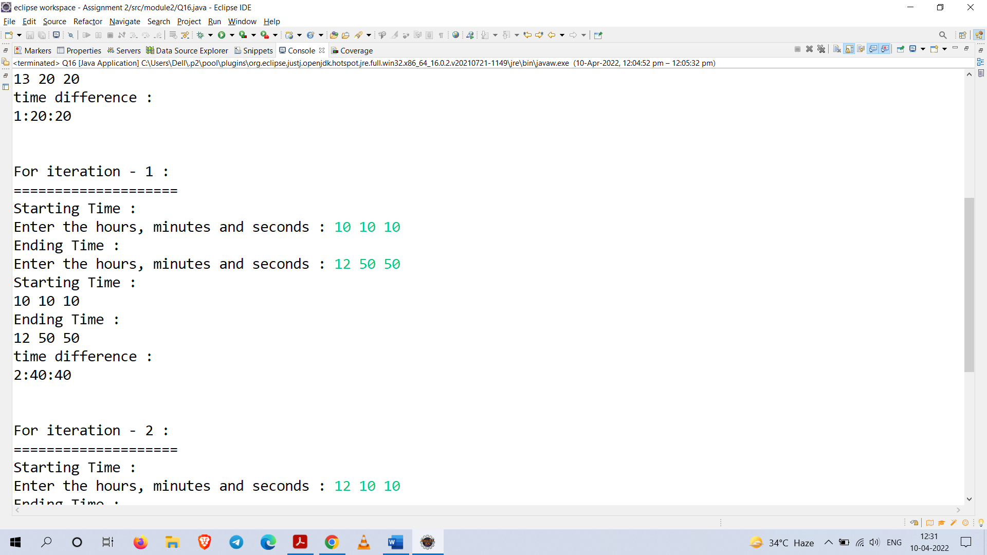

Part 3

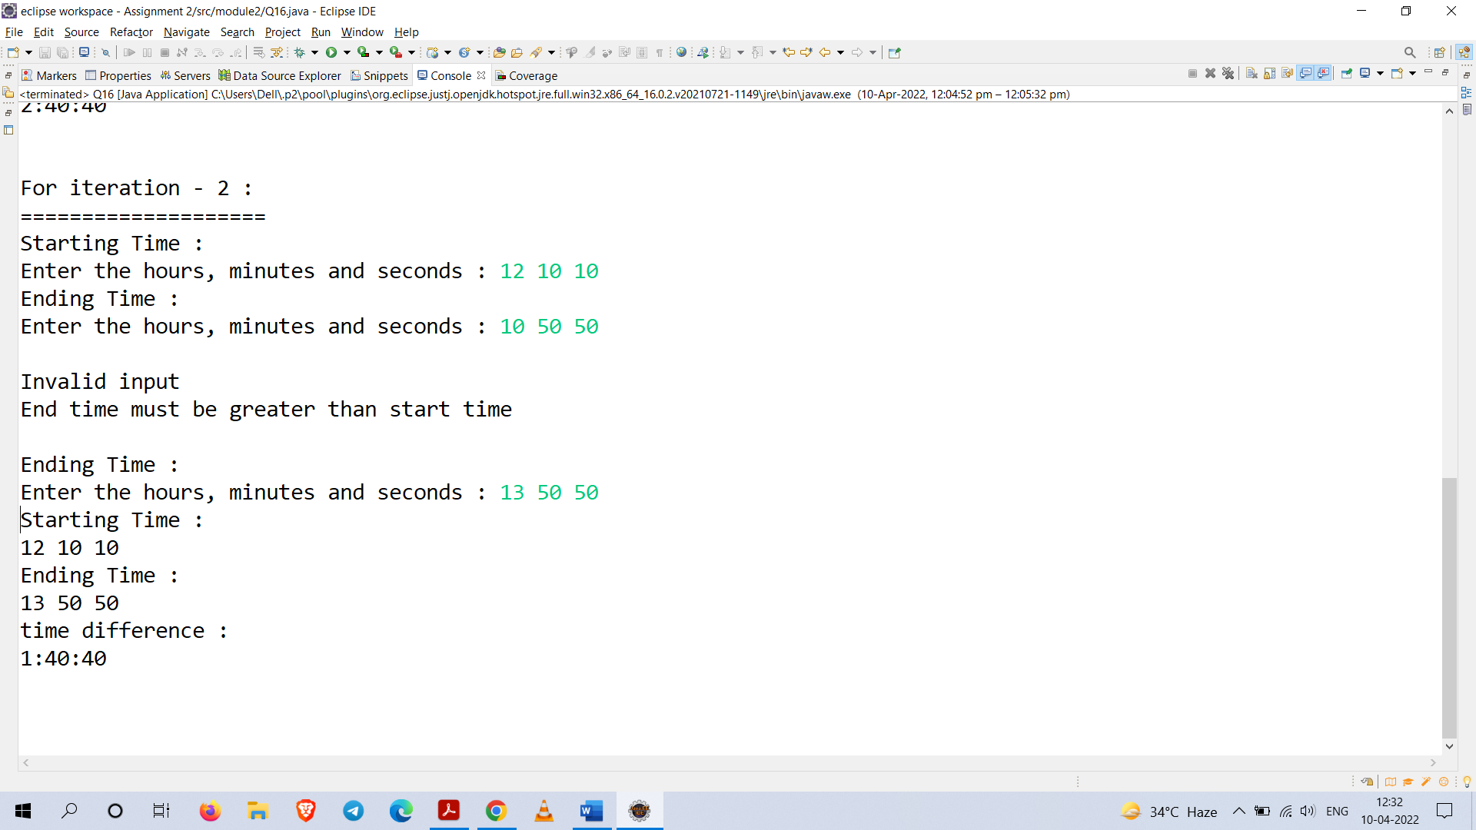

**Q18.** Design a Java program with your choice of a class to represent any real-world object. Illustrate *constructors* and *this* keyword.

**Code :**

**package** module2;

**import** java.util.Scanner;

**public** **class** Q18 {

**private** **int** sid;

**private** String firstName;

**private** **int** rollNumber;

**static** **int** *count*=1000;

Q18(String x, **int** y){

*count*++;

sid = *count*; //auto-generated sid

**this**.firstName = x;

**this**.rollNumber = y;

}

**public** **void** outputInfo() {

System.***out***.println("Student ID : "+sid);

System.***out***.println("Name : "+firstName);

System.***out***.println("Roll Number : "+rollNumber);

System.***out***.println("============================");

}

**public** **static** **void** main(String[] args) {

Scanner sc = **new** Scanner(System.***in***);

System.***out***.print("Enter number of student : ");

**int** n = sc.nextInt();

System.***out***.println();

Q18 o[] = **new** Q18[n];

**for**(**int** i = 0 ; i < n ; i++) {

System.***out***.print("Enter your first Name : ");

String x = sc.next();

System.***out***.print("Enter your roll Number : ");

**int** y = sc.nextInt();

System.***out***.println();

o[i] = **new** Q18(x,y);

}

System.***out***.println("\nOutput : ");

System.***out***.println("============================");

**for**(Q18 z : o) {

z.outputInfo();

}

sc.close();

}

}

**Output :**

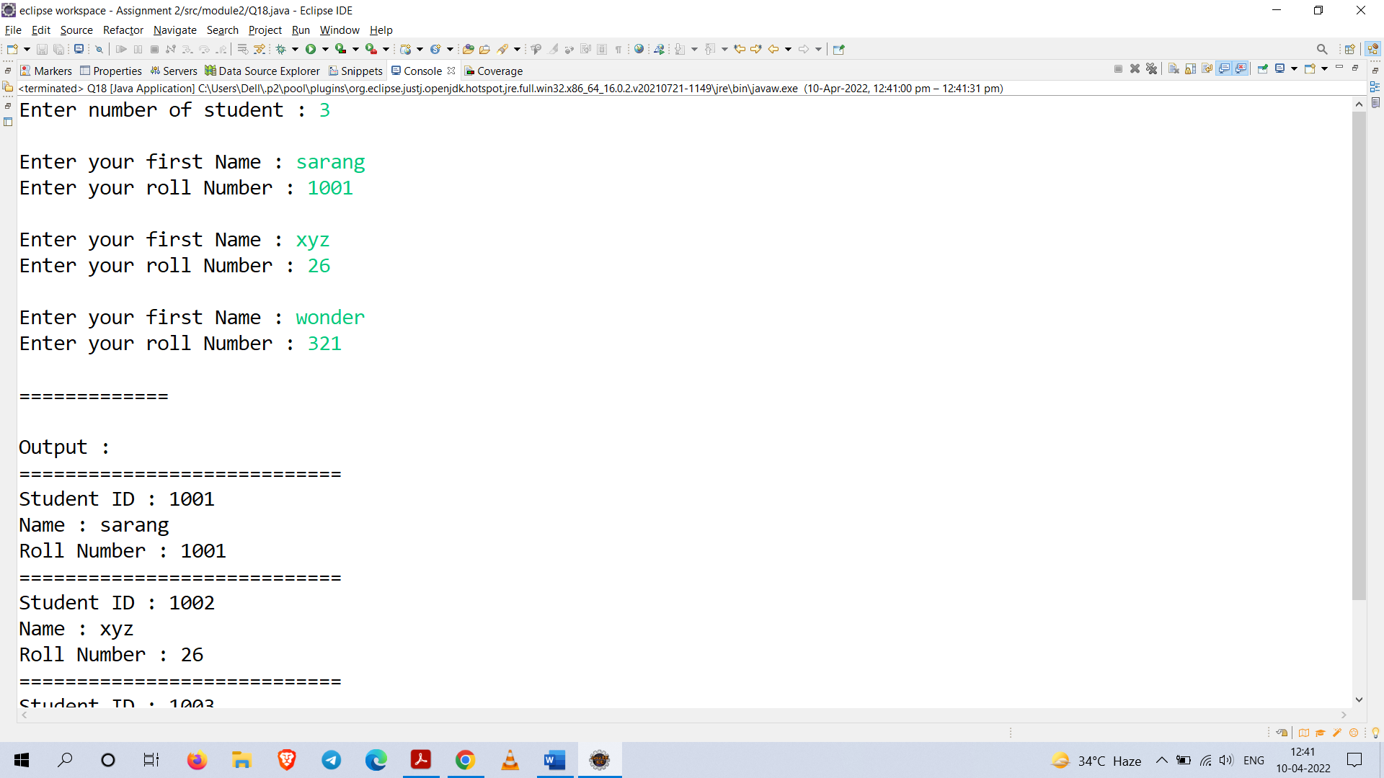

**Q19.** Design a Student class which contains register number, name, marks for three courses, average and result. Define methods to get input, print details, find the average and result (if mark is more than 49 in all courses then Pass, otherwise Fail). Keep input methods and print methods as public while others are private. Create array of objects for the Student class and demonstrate those methods.

**Code :**

**package** module2;

**import** java.util.Scanner;

**public** **class** Student {

**static** Scanner *sc* = **new** Scanner(System.***in***);

**private** **int** registerNumber;

**private** String name;

**private** **float** m1,m2,m3;

**private** **float** average;

**private** **static** **int** *count*;

**private** **static** **boolean** *value*;

**private** **float** sum;

**public** **void** input() {

System.***out***.print("Enter registerNumber : ");

registerNumber = *sc*.nextInt();

System.***out***.print("Enter Name : ");

name = *sc*.next();

*value* = **false**;

**while**(*value* != **true**) {

System.***out***.print("Enter Marks for subject 1 : ");

m1 = *sc*.nextInt();

System.***out***.print("Enter Marks for subject 2 : ");

m2 = *sc*.nextInt();

System.***out***.print("Enter Marks for subject 3 : ");

m3 = *sc*.nextInt();

**if**(m1 > 100 || m2 > 100 || m3 > 100 || m1 < 0 || m2 < 0 || m3 < 0)

*value* = **false**;

**else**

*value* = **true**;

**if**(*value* == **false**)

System.***out***.println("Invalid\nPlease try again...");

}

}

**private** **void** process() {

sum = m1 + m2 + m3;

average = (sum)/3;

}

**public** **void** output() {

*count*++;

System.***out***.print(*count*+") "+registerNumber+" "+name);

System.***out***.print(" "+sum+" "+average+" ");

**if**(m1 > 49 && m2 > 49 && m3 > 49)

System.***out***.print("Pass");

**else**

System.***out***.print("Fail");

System.***out***.println();

}

**public** **static** **void** main(String[] args) {

System.***out***.println("Enter the number records to be filled : ");

**int** n = *sc*.nextInt();

Student s[] = **new** Student[n];

**for**(**int** i = 0 ; i < n ; i++) {

s[i] = **new** Student();

System.***out***.println("\nData for student "+(1+i));

s[i].input();

s[i].process();

}

System.***out***.println("Record : ");

**for**(Student l : s) {

l.output();

}

*sc*.close();

}

}

**Output :**

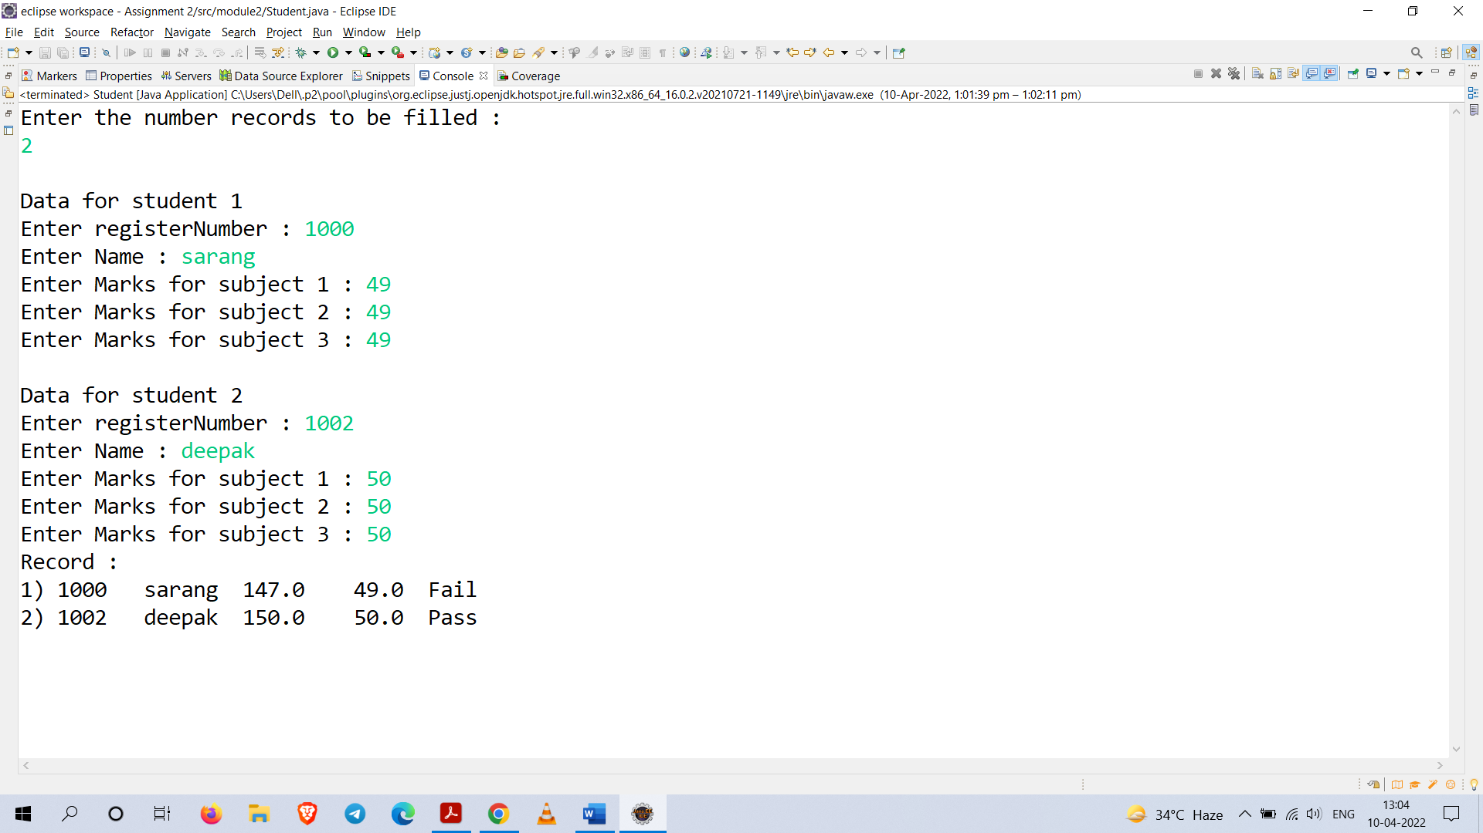

**Q20.** Design a class to store account details of a person like account number, name, account type, available balance and minimum balance. Define methods to get input, display account details, show balance, deposit and withdraw. Apply the condition while withdraw money from account that the minimum balance to be maintained. Create a demo class in Java to demonstrate these methods with minimum of 3 objects.

**Code :**

**package** module2;

**import** java.util.Scanner;

**public** **class** Q20 {

**static** Scanner *sc* = **new** Scanner(System.***in***);

**public** **int** accNumber;

**public** String name;

**public** String accType;

**public** **float** balance;

**public** **float** minBalance;

**public** **float** deposit;

**public** **float** withdraw;

**public** **void** setInput() {

System.***out***.print("Account Number : ");

accNumber = *sc*.nextInt();

System.***out***.print("First Name : ");

name = *sc*.next();

System.***out***.print("Account Type : ");

accType = *sc*.next();

System.***out***.print("Balance : ");

balance = *sc*.nextFloat();

System.***out***.print("Minimum Balance : ");

minBalance = *sc*.nextFloat();

}

**public** **void** getOutput() {

System.***out***.println("==================================");

System.***out***.println("Name : "+name);

System.***out***.println("Account Number : "+accNumber);

System.***out***.println("Account type : "+accType);

System.***out***.println("Current Balance : "+balance);

System.***out***.println("==================================\n");

}

**public** **void** showBalance() {

System.***out***.println("\nCurrent Balance : "+balance);

}

**public** **void** deposit(){

System.***out***.println("==================================");

System.***out***.println("Enter the amount to be deposit : ");

deposit = *sc*.nextFloat();

balance+=deposit;

showBalance();

}

**public** **void** withdraw() {

System.***out***.println("==================================");

System.***out***.println("Enter the amount to be withdraw : ");

withdraw = *sc*.nextFloat();

**if**(withdraw > (balance - 2500)) {

System.***out***.println("Account balance is insufficient.");

}

**else**

balance-=withdraw;

showBalance();

}

**public** **static** **void** main(String[] args) {

Q20 a[] = **new** Q20[3];

**for**(**int** i = 0 ; i < 3 ; i++)

{

a[i] = **new** Q20();

a[i].setInput();

a[i].deposit();

a[i].withdraw();

a[i].getOutput();

}

*sc*.close();

}

}

**Output :**

Part 1

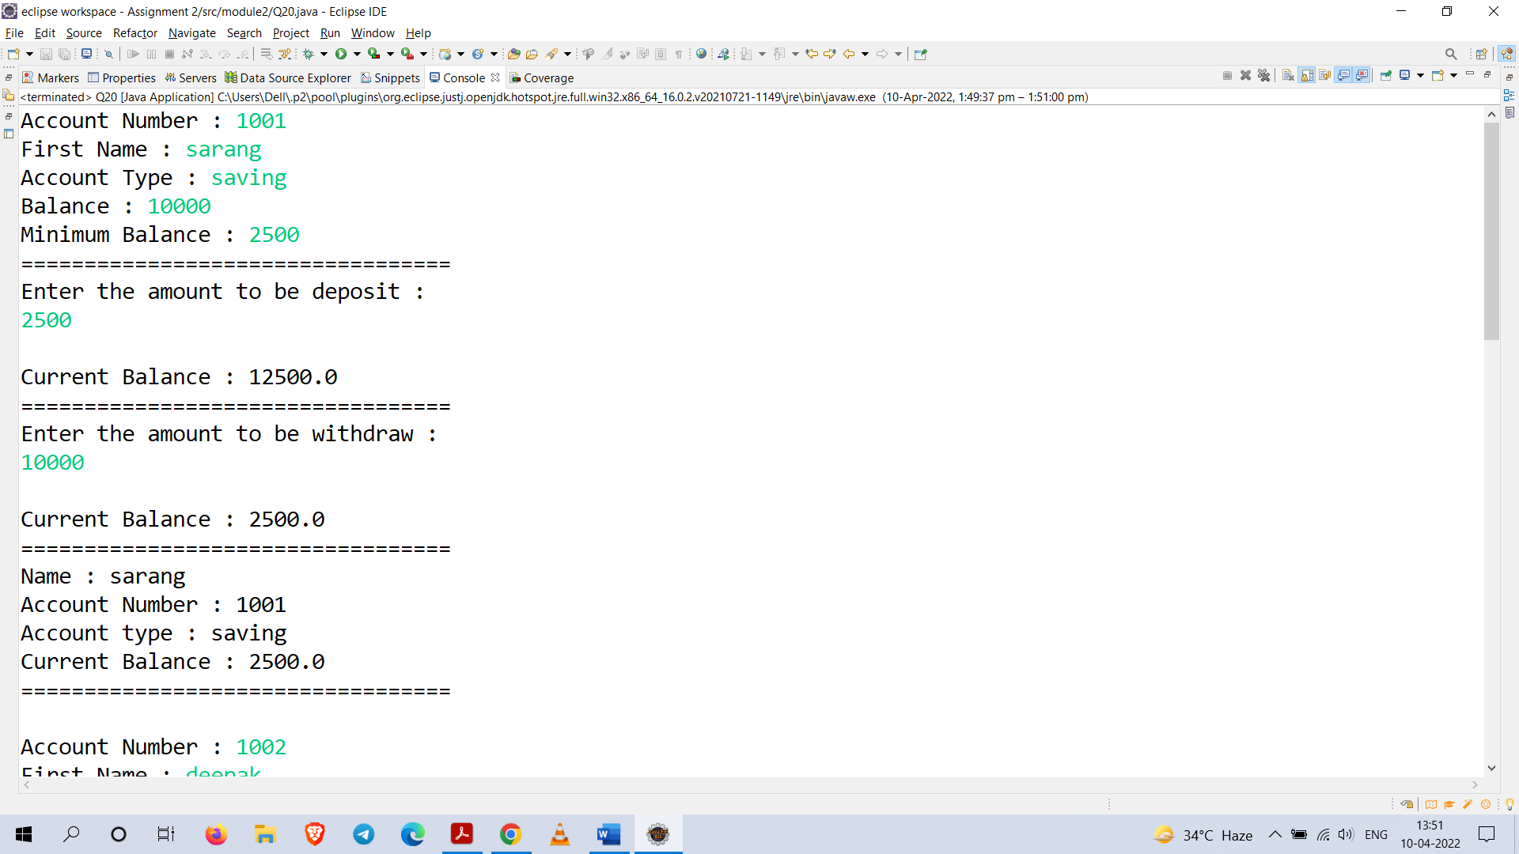

Part 2

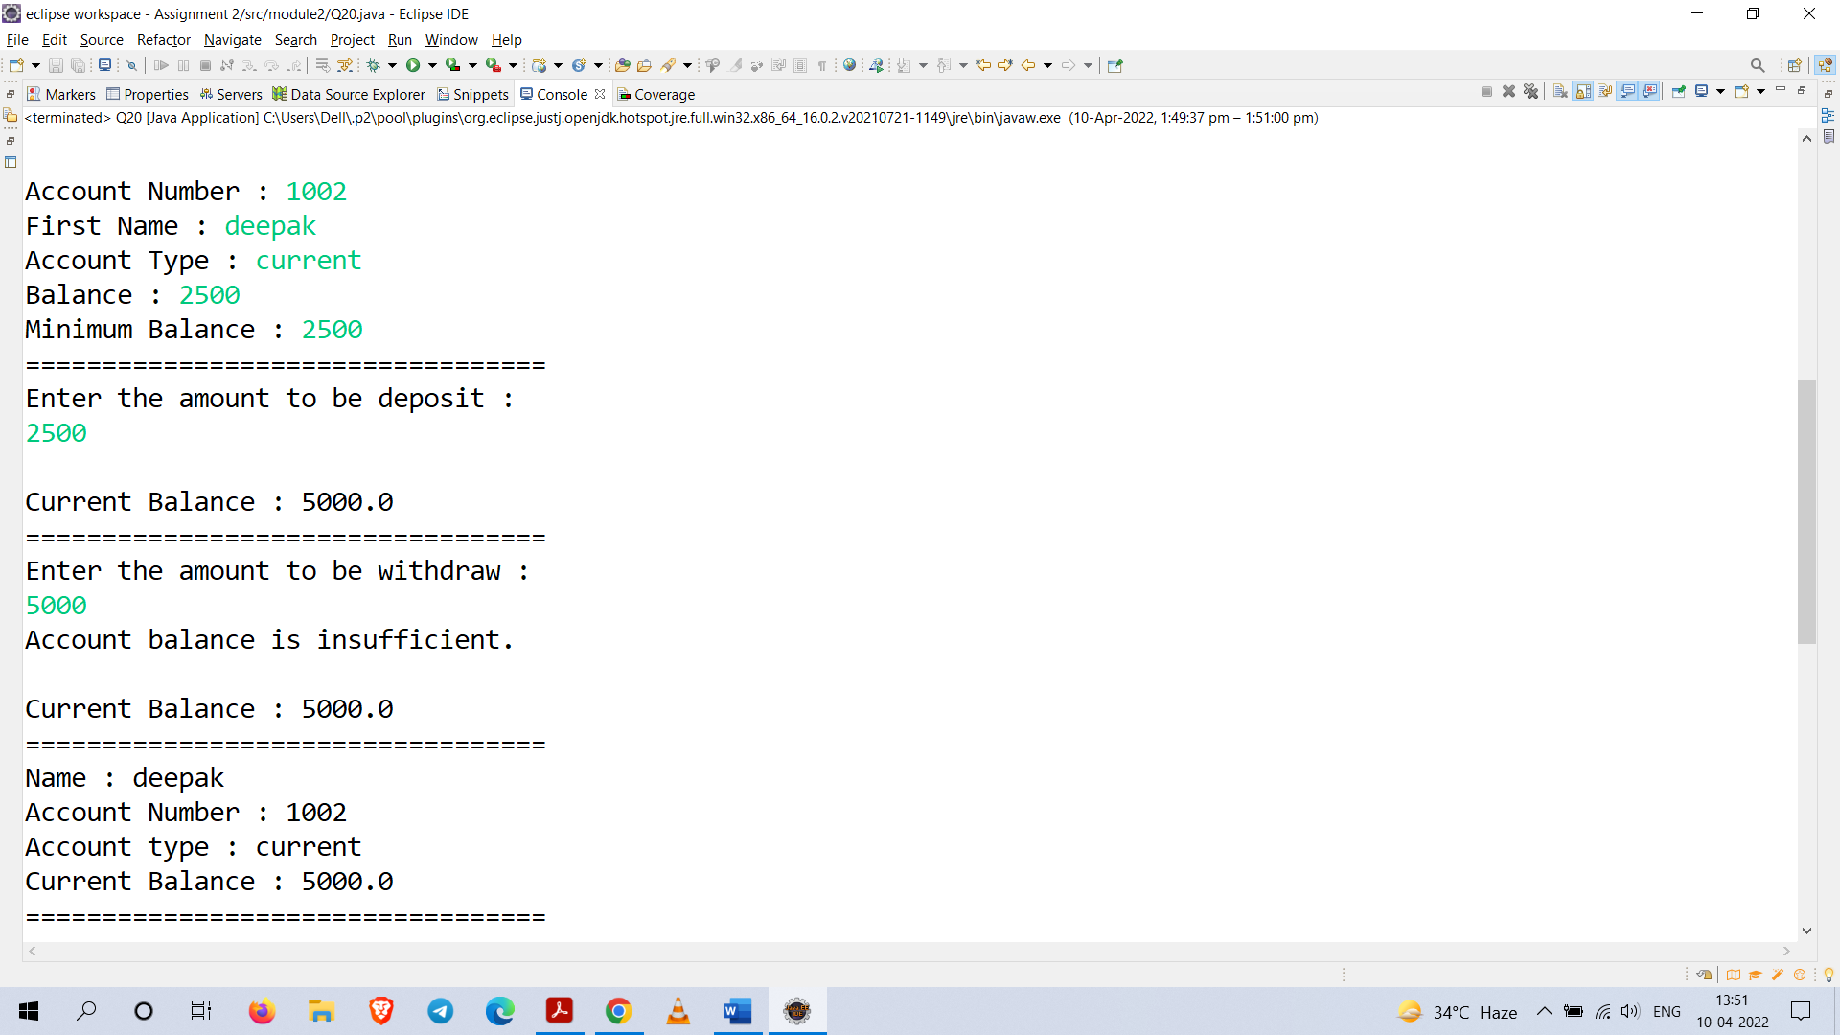

Part 3

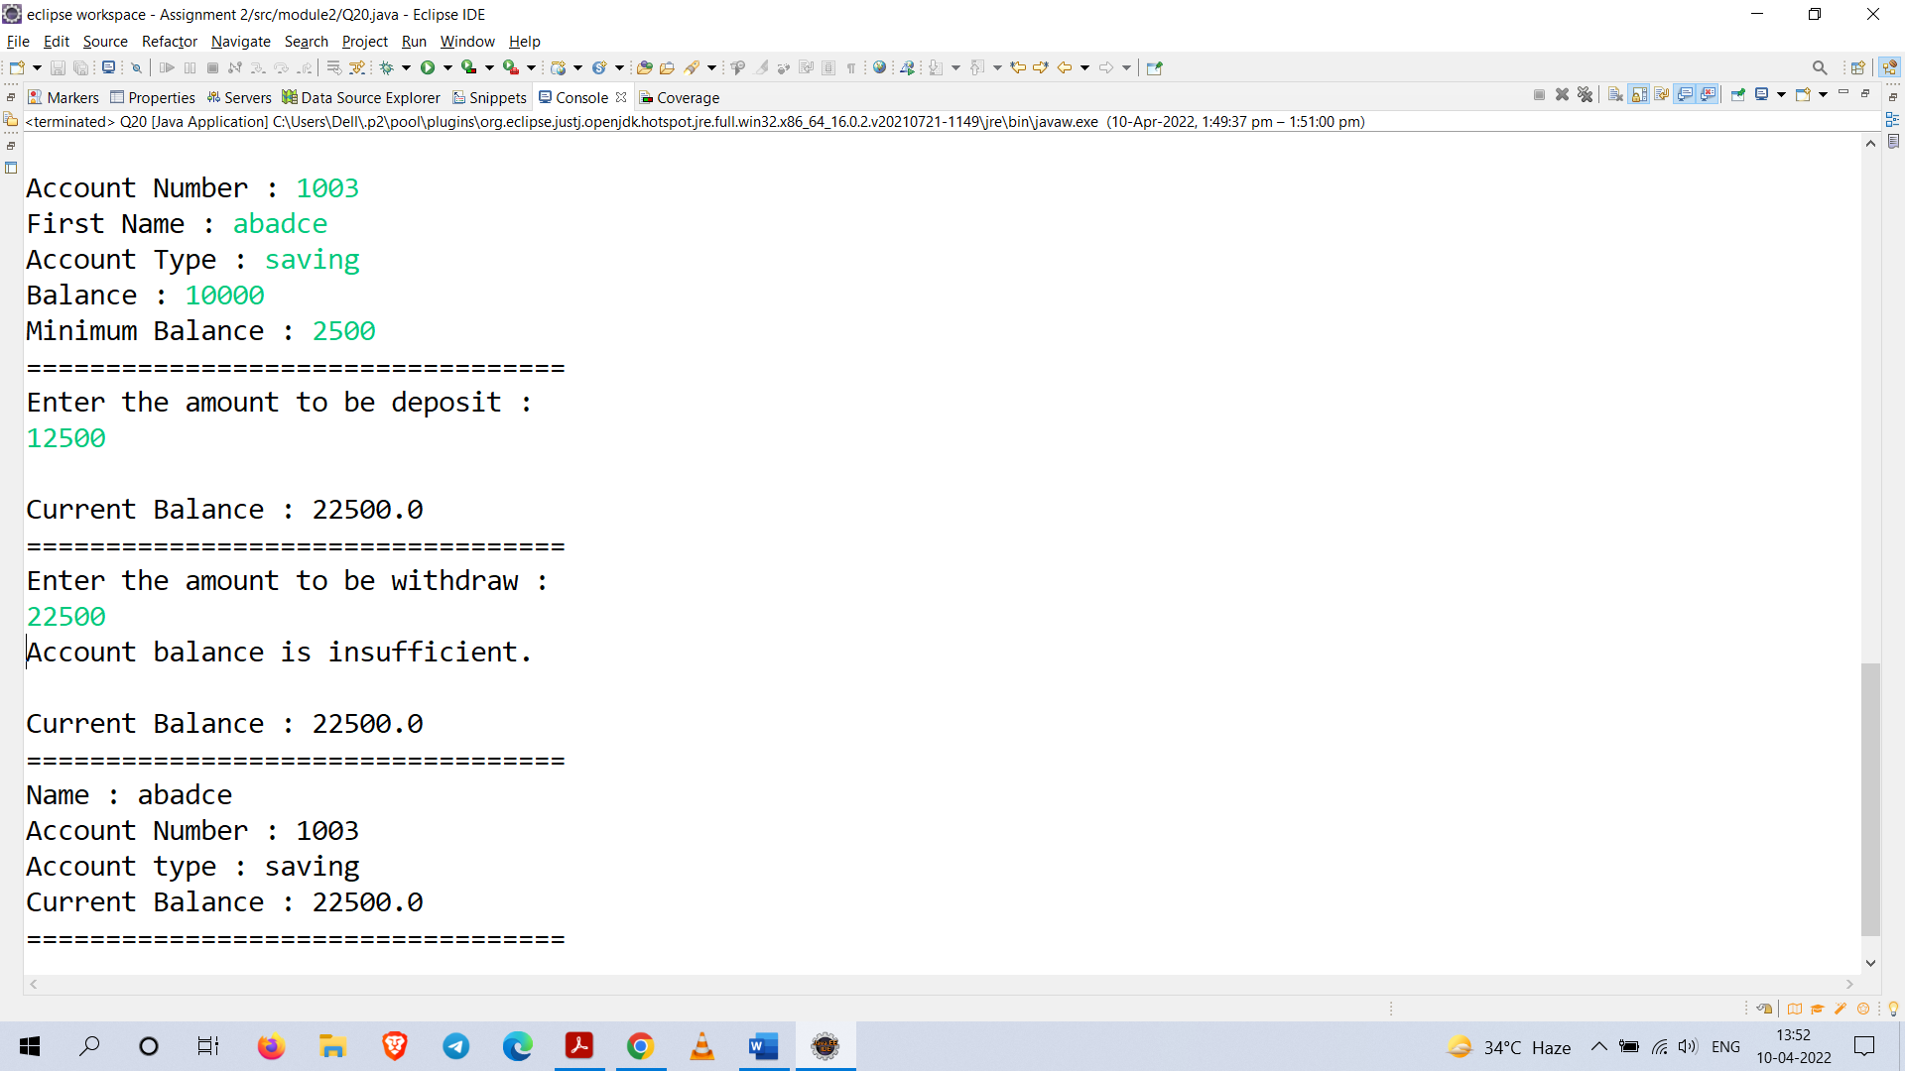

**Q22.** Using loop statement write a program that prompts the user to enter 5 integer values:

1. Find and display the Largest and Smallest number
2. Display whether the number is Even or Odd
3. Display whether the number is negative, positive or zero
4. Calculate the Sum and Average of the Even numbers

**Code :**

**package** module2;

**import** java.util.Scanner;

**public** **class** Q22 {

**static** **int** *largest*;

**static** **int** *smallest*;

**static** **int** *input*[] = **new** **int**[5];

**static** Scanner *sc* = **new** Scanner(System.***in***);

**static** **int** *even*;

**static** **int** *odd*;

**static** **int** *sum*;

**public** **void** input() {

System.***out***.println("Enter 5 integers (hit enter after each input): ");

**for**(**int** i = 0 ; i < 5 ; i++) {

System.***out***.print("=>");

*input*[i] = *sc*.nextInt();

}

}

**public** **void** largeSmall() {

*largest* = *input*[0];

*smallest* = *input*[0];

System.***out***.println("\nLargest and Smallest : ");

System.***out***.println("=========================");

**for**(**int** i = 1 ; i < *input*.length ; i++)

{

**if**(*input*[i] > *largest*)

*largest* = *input*[i];

**if**(*input*[i] < *smallest*)

*smallest* = *input*[i];

}

System.***out***.println("Largest Number is : "+*largest*);

System.***out***.println("Smallest Number is : "+*smallest*);

}

**public** **void** evenOdd() {

System.***out***.println("\nEven and Odd : ");

System.***out***.println("==================");

**for**(**int** i = 0 ; i < *input*.length; i++) {

**if**(*input*[i] % 2 == 0) {

*even* = *input*[i];

System.***out***.println(*input*[i]+" is even");

*sum*+=*even*;

}

**else** {

*odd* = *input*[i];

System.***out***.println(*input*[i]+" is odd");

}

}

}

**public** **void** negiPosi() {

System.***out***.println("\nNegative, Positive and Zero : ");

System.***out***.println("===================================");

**for**(**int** i = 0 ; i < *input*.length ; i++) {

**if**(*input*[i] < 0) {

System.***out***.println(*input*[i]+" is Negative");

}**else** **if**(*input*[i] > 0) {

System.***out***.println(*input*[i]+" is Positive");

}**else** **if**(*input*[i] == 0) {

System.***out***.println(*input*[i]+" is Zero");

}

}

}

**public** **void** sumAvg() {

System.***out***.println("\nSum and Average : ");

System.***out***.println("======================");

System.***out***.println("Sum of even numbers : "+*sum*);

System.***out***.println("Average of even number : "+(*sum*/3));

}

**public** **static** **void** main(String[] args) {

Q22 q = **new** Q22();

q.input();

q.largeSmall();

q.evenOdd();

q.negiPosi();

q.sumAvg();

*sc*.close();

}

}

**Output :**

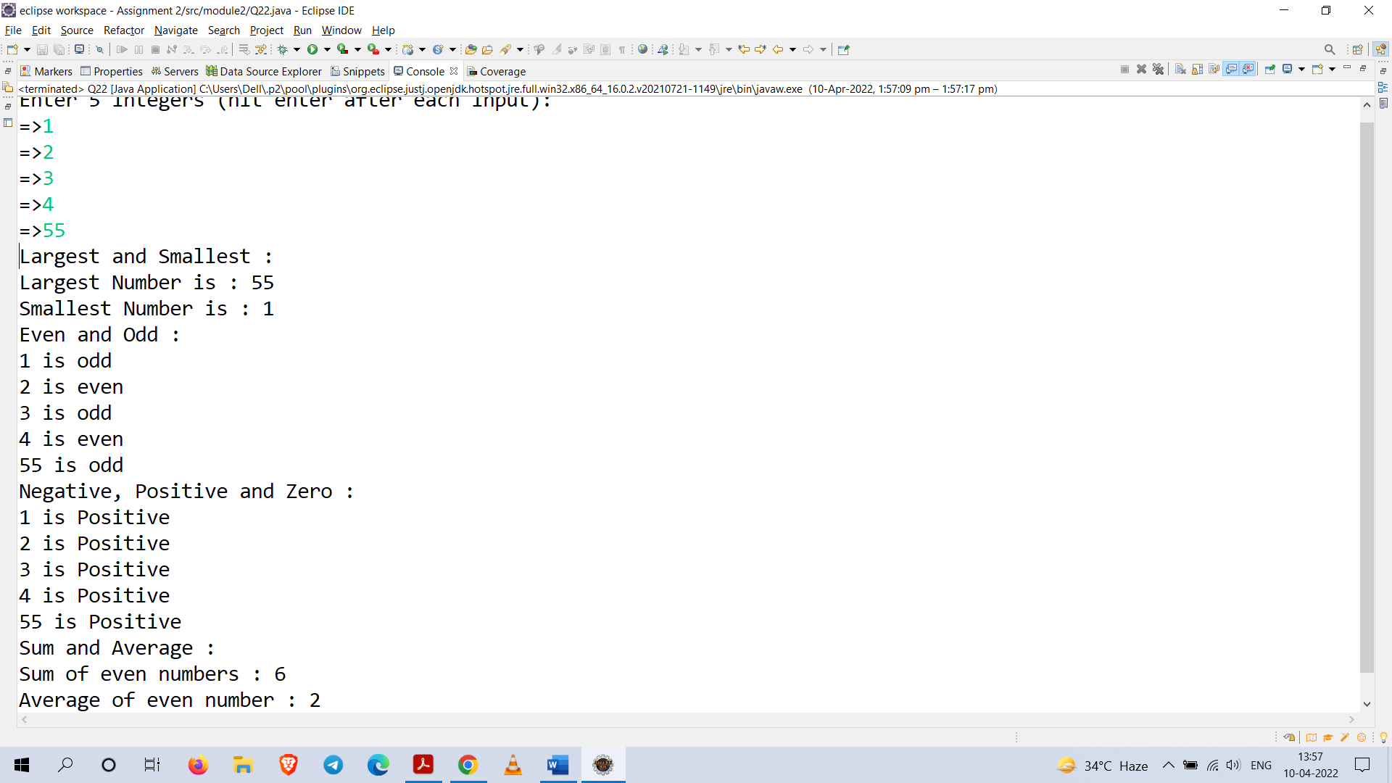

**Q23.** Write a program that randomly generates an integer between 0 and 100, inclusive. The program prompts the user to enter a number continuously until the number matches the randomly

generated number. For each user input, the program tells the user whether the input is too low

or too high, so the user can choose the next input intelligently.

**Code :**

**package** module2;

**import** java.util.Scanner;

**public** **class** Q23 {

**static** **int** *guess*;

**static** **int** *input*;

**static** Scanner *sc* = **new** Scanner(System.***in***);

**public** **static** **void** main(String[] args) {

*guess* = (**int**) (Math.*random*() * 101);

System.***out***.println("Guess the Number between 0 to 100 :");

System.***out***.print("=>");

*input* = *sc*.nextInt();

**while**(*input* != *guess*)

{

**if**(*input* < *guess*) {

System.***out***.println("input is too low.");

}**else** **if**(*input* > *guess*) {

System.***out***.println("input is too high.");

}

System.***out***.println("=============");

System.***out***.println("Try again : ");

System.***out***.print("=>");

*input* = *sc*.nextInt();

}

**if**(*input* == *guess*) {

System.***out***.println("Correct guess.");

}

*sc*.close();

}

}

**Output :** 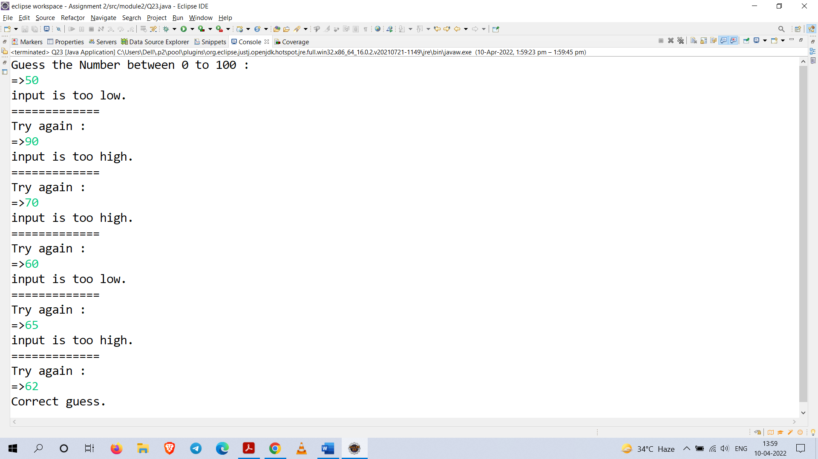

**Q24.** Write a class named Duplicate that use a method named..... long duplicateDigits(long n) that,

given a long integer n that is here guaranteed to be positive, returns the integer constructed by

writing its digits twice in a row.

For example, when called with argument 1504, this method would return 15041504. You may

not convert n to a string at any time, but must calculate the answer using only loops, conditions

and basic integer arithmetic.

Your method must work correctly for all positive values of n less than one million.

(Hint: think of how you would check whether n consists of one digit, and how you would

calculate the duplicated number in such case. Then think of two digits, three digits, four digits

and higher until you can see and can implement the general pattern.)

**Code :**

**package** module2;

**import** java.util.Scanner;

**public** **class** Duplicate {

**public** **long** duplicateDigits(**long** n) {

**long** num = n;

**int** count = 0, multiple=1;

**while**(num>0) {

num/=10;

count++;

}

**while**(count!=0) {

multiple*=10;

count--;

}

num=(n*multiple)+n;

**return** (**int**)num;

}

**public** **static** **void** main(String[] args) {

**long** n=-1;

Scanner sc = **new** Scanner(System.***in***);

**while**(n<=0) {

System.***out***.println("Enter positive number : ");

n = sc.nextLong();

}

Duplicate dup = **new** Duplicate();

**int** result = (**int**)dup.duplicateDigits(n);

System.***out***.println("Result : "+result);

sc.close();

}

}

**Output :**

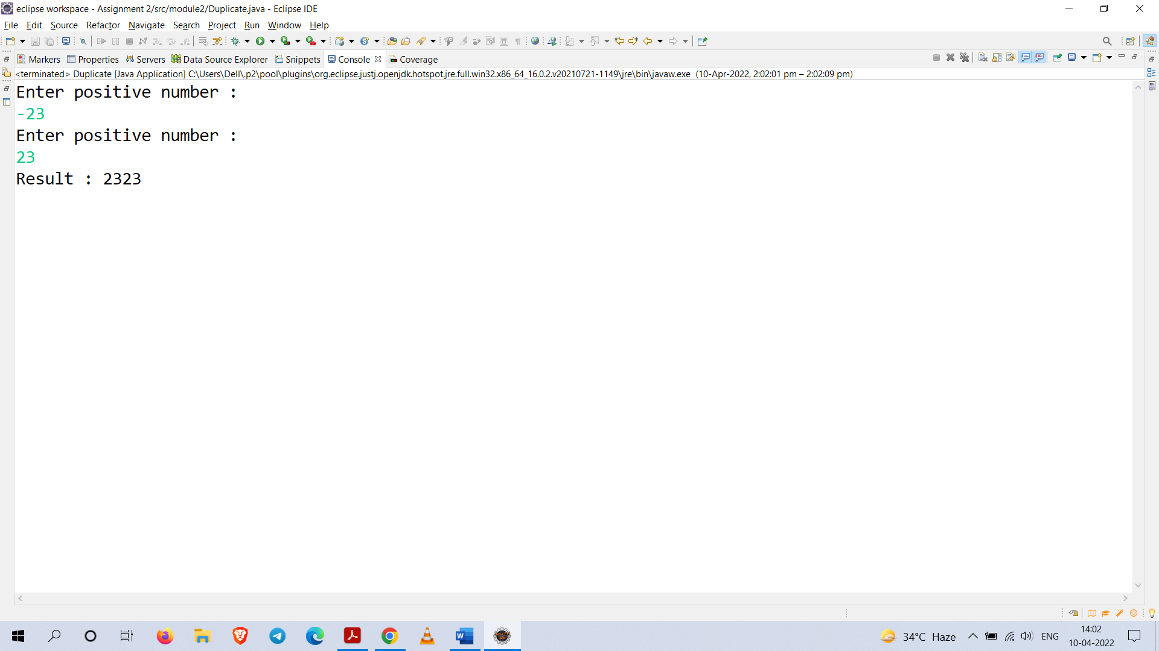

**Q25.**

**Code :**

**package** module2;

**import** java.util.Scanner;

**public** **class** Mean {

**static** Scanner *sc* = **new** Scanner(System.***in***);

**static** **int** *n*;

**static** **double** *x*[];

**static** **double** *sum*;

**static** **double** *mean*;

**public** **void** input() {

System.***out***.println("Enter 10 numbers : ");

*x* = **new** **double**[10];

**for**(**int** i = 0 ; i < *x*.length ; i++) {

*x*[i] = *sc*.nextDouble();

}

*n* = *x*.length;

}

**public** **void** mean() {

**for**(**int** i = 0 ; i < *x*.length ; i++) {

*sum*+=*x*[i];

}

*mean* = *sum* / *n*;

System.***out***.println("The mean is : "+*mean*);

}

**public** **void** deviation() {

**double** numerator = 0;

**for**(**int** i = 0 ; i < *x*.length ; i++) {

numerator += ((*x*[i] - *mean*) * (*x*[i] - *mean*));

}

**double** deviation = Math.*sqrt*(numerator/(*n*));

System.***out***.println("The standard deviation is : "+deviation);

}

**public** **static** **void** main(String[] args) {

Mean m = **new** Mean();

m.input();

m.mean();

m.deviation();

*sc*.close();

}

}

**Output :**

